OZONESONDE FLIGHT PREPARATIONS

Table of Contents

Notes 3
A week before flight preparations 4
Changing the sensor solution 4
Measuring background current 5
Day of flight preparation 7
Closing the Styrofoam box 9
Preparing the computer 11
TrueTTY configurations 11
O3 configurations 12
Things that might go wrong and troubleshooting 15
Preparing the ground antenna 16

NOTES
- The first step in preparing the ozonesonde for use is to check the overall performance of the instrument, and to charge the sensor with sensing solution (Appendix A in the original manual). Initial charging of the sensor should be done 3 days to 1 week before flight time in order to attain a low sensor background current.
- You should also prepare the ozonesonde 1-20 hours before flight. If you haven’t done so, you will have to rely in putting the chemicals last minute and the ozonesonde may not function the same way (according to the manual), but you can do it if you are not so concerned about data and are just performing other tests, etc.
- We still do not have the calibrator for the ozonesonde, therefore we have been improvising in testing it and preparing for flight. This manual will give the procedures we currently use as our preparation for flight;
- The preparation should be performed in a clean room at a temperature of 20-25 C
- There are 4 steps (with sub-steps) in the ozonesonde manual that refers to calibration with the “Ozonizer” (the ozonesonde calibrator). Once you already have it, please refer to the Ozonesonde manual (pages 8-9) for steps a to d before charging the sensor (chemical cell) with solution. We are moving on to step e in the manual for this reason.

P.S: REFER TO THE OZONESONDE MANUAL FOR DETAILED DESCRIPTION OF ALL TESTING AND PROCEDURES FOR FLIGHT. THIS IS AN ATTEMPT TO MAKE LIFE EASIER IF THE OZONESONDE TEAM IS ABSENT DURING OR BEFORE A FLIGHT.

A WEEK BEFORE FLIGHT PREPARATIONS
- Unplug the sensor leads from the sonde electronic interface board and unscrew the chemical cell from the ozonesonde. DO NOT LOSE THE SHORTING PLUG!!! Use the proper sized pliers to pull the plastic caps from the cells and set it aside. Empty the compartments and wash it thoroughly with tap water;
- Wash it again with distilled water. Wash the caps as well, making sure to inject distilled water in the Teflon tubes by using one of those plastic bottles with a tip (there should be one inside the ozonesonde box or in the electronics lab. Finally, clean the pump tubes with methanol;
- The sensor cathode must always be charged first to allow cathode solution to permeate the sensor's ion bridge. There is an “A” marked with a black marker for the anode cell. Using a Teflon-tipped syringe especially reserved for use with cathode sensing solution (inside a plastic bag in the ozonesonde box – HARBOR room), inject 3.0 ml of the solution into the sensor cathode chamber. WAIT 2 MINUTES BEFORE PROCEEDING WITH THE ANODE SOLUTION to allow the cathode sensing solution to permeate the sensor’s ion bridge.

The solutions (anode and cathode) could be in the dark room (electronics lab) or inside the ozonesonde box in the HARBOR room. They are brown (dark bottles) because the solutions are sensitive to light. Agitate them before using. Make sure to clean the syringes after use with distilled water.

When re-installing the top plug of the cathode, make sure that the air intake tube is correctly centered within the cathode chamber by inserting the tube carefully over a thin Teflon rod projecting out of the bottom plug of the sensor cathode chamber. IT IS A VERY FRAGILE ROD!

Note: Do not attempt to fill or empty the sensor cathode through the short air exhaust tube of the cathode chamber top plug; otherwise the platinum screen may be damaged (distorted), leading to sensor malfunction.
- After waiting 2 minutes, use a syringe especially reserved for dispensing anode solution to inject 1.5 ml anode sensing solution into the sensor anode chamber. Rinse the syringe with distilled water prior to storage.
- After charging the sensor with solution, screw the chemical cell back on the ozonesonde and run the sonde on ozone-free air for 5-10 minutes. If you still don’t have the Ozonizer, improvise by using a box of some sort to cover the ozonesonde. Please do the following:
  - Take the ozonesonde from the foam box. Disconnect the sensor leads from the electronics board and connect to the DMM labeled “O3” (on the bottom), usually located at last station in the electronics lab, or use another one that is accurate to hundredths of microamps. Make sure it is set to measure microamps (current). Finally, cover the ozonesonde with the box, over the DMM leads, leaving very little space for air to go in and tape it all around. I usually use one of Dr. Sohl’s plastic storage box that contains used batteries. It is usually located in his electronics lab. Any box will do it though, as long as it has no holes
  - Monitor the levels of ozone in the computer (see next section for instructions on how to set the system for flight). When it reaches a number that is as close to zero as possible, let it run for 10 minutes and watch the current. It should not be more than 0.5 µA. It has never been over 0.2 µA for me.
  - Now we need to test for high levels ozone current. Take the box off and spark high voltage with the Tesla Coil Dr. Sohl has in his lab. Be extremely careful because there is no switch button and it hurts if you have an accident! Spark it on a metal (like the chairs around), as close as possible to the ozonesonde pump. Observe the current in the DMM. When it reaches 5 µA, keep it around that number for about 5 to 10 minutes, or as long as possible up to 10 minutes. Stop and immediately put the box back. Count 1 minute and watch the current. It should have dropped to 1.5 µA or less. Remember that these steps are being done in an unusual way and differences may occur. I have been able to obtain the expected result or very close to it though. This test will indicate satisfactory performance of the ozonesonde.
  - Allow it to run for 10 more minutes inside the box and turn it all off. Disconnect the leads from the electronics board and short them with the plug.
  - Open the cathode chamber again and insert 2.5 ml of cathode solution. Close it and store the ozonesonde in a dark room until the day of flight (up to 20 hours before).

DAY OF FLIGHT PREPARATION (1-20 HOURS BEFORE LAUNCH)
- Use old batteries for testing and replace the batteries right before flight!!!
- For details in how to change the solutions and measure background current, refer to “A WEEK BEFORE FLIGHT PREPARATIONS” above.
- Change cathode (3.0ml) and anode (1.5ml) solutions – as previously instructed;
- Measure pump pressure by using the barometer (ozonesonde box in HARBOR room). To do that, disconnect the Teflon tube from the pump (the one that connects the pum to the chemical cell) and turn on the ozonesonde. The pressure should be above 8psi or else disregard sonde.
- Measure and record background current on low ozone air as previously instructed (inside box). You will need this information to input into the O3 program before flight!
- Expose ozonesonde to 5 microamps ozone for 10 minutes.
- Measure decay time (as previously instructed);
- Measure T100 flow rate - this test has not been performed yet, but there are instructions in the manual (Flow Rate Test). The apparatus is in the ozonesonde box (HARBOR room). Refer to original ozonesonde manual for complete instructions;
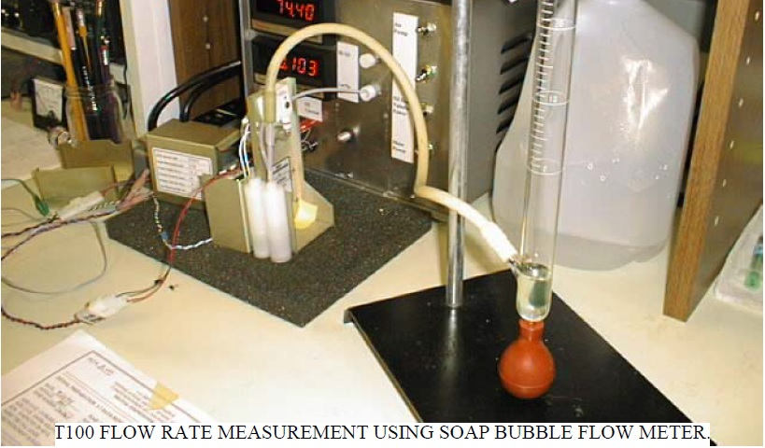

- Record room temperature and humidity (use HARBOR sensor). You will need this information to input into the O3 program before flight.
- Prepare the laptop (instructions on page 8) and antenna (there should be a team preparing the antenna). If nobody, refer to page 14 in this manual);
- Connect radiosonde to ozonesonde. Connect cell leads to board. There is a filter we should run 4-10 minutes before flight, but we haven’t done that yet. The filter is inside the ozonesonde box (HARBOR room);
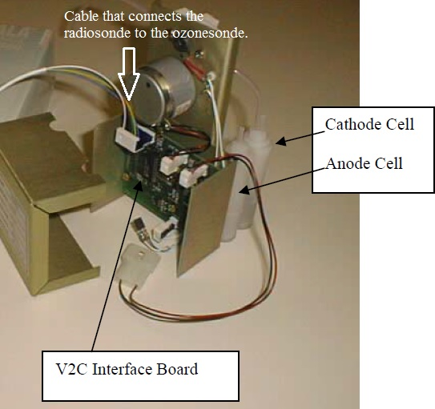
Metal box that covers the electronics board

Ozonesonde picture

- Replace the metal cover on ozonesonde (look into the picture above);
- Place ozonesonde instrument inside Styrofoam box. Make sure everything follows the proper positioning inside, marked in black – for center of mass;
- Make sure the radiosonde and ozonesonde have new batteries before flight;
- Close the box for flight as follow:
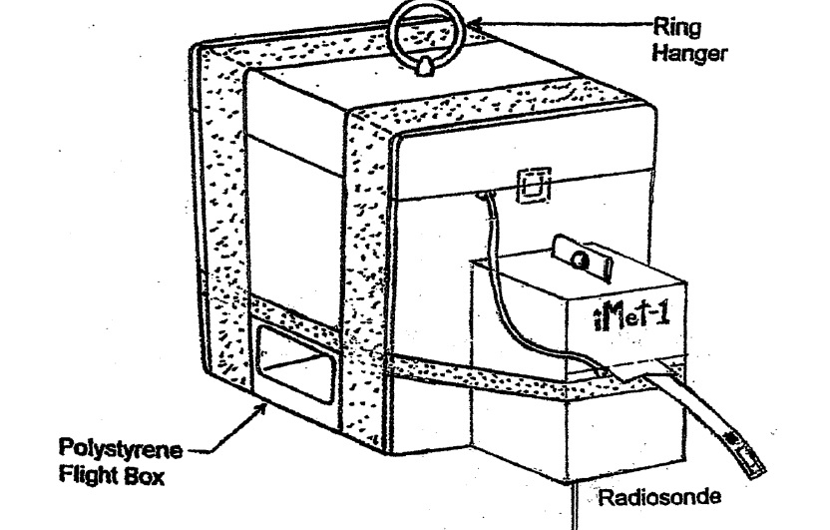
- Run ozonesonde outside to obtain 5-10 minute surface ozone measurement.
- Attach to balloon train.
- Check that Antenna is down.
- Release ozonesonde. Record GMT date and time of launch.
- Track data through ascent and on descent until signal fades.
- Recondition ozonesonde for next flight (refer to original ozonesonde manual for instructions).

Reject Sonde if: 1. Background is >0.10 microamps.
2. Background is negative < -0.02 microamps.
3. T100 time is <24 seconds, or > 34 seconds – test has not been performed yet
4. Pump pressure is < 8 psi.
5. Pump current is > 125 milliamps (can be measured using the O3 program)

PREPARING THE COMPUTER
- Open Nathaniel’s laptop (or another laptop that contains the entire ozonesonde system);
- Open the folder (that should be on desktop for easy access) “Ozonesonde” or similar. All the needed programs executables will be right there;
- Open “VSPE” – it’s the virtual port emulator. If it asks to purchase the license, ignore it and say “no”.
  - Click on “create new device” – it’s a connector icon with a red star.
  - Choose “pair” and click “next”;
  - Choose any two different ports and click “finish.” It should say “ready” under “status”. Minimize the window and go back to the ozonesonde folder.
- Open “TrueTTY” – it’s the software that substitutes the modem. It will decode the signal and send it to the O3 program. Follow the instructions in the chart next page. “Intermet RSB1” is our Radiosonde brand. The “setup” option should be already all correct, but double check.
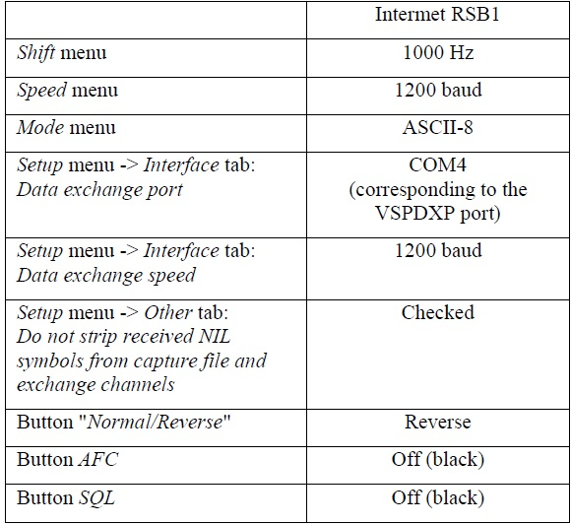

- Still on TrueTTY program, make sure that you set the correct COM port you assigned in your VSPE. You are sending the signal from TrueTTY to the O3. So, if you set COM1 and COM2 in your VSPE program, you can designate COM1 for TrueTTY and COM2 for the O3 program (which is the next we will open).
- Open the “O3” program. Press “start” button.
  - Change anything you want to change in that window: Name, latitude, longitude, and altitude.
  - Click on “Radiosonde” menu. Change the info if wanted.
  - Click on “Ozonesonde” label. The information you need to input is with the ozonesonde, on the metal cover that protects the electronic’s interface:
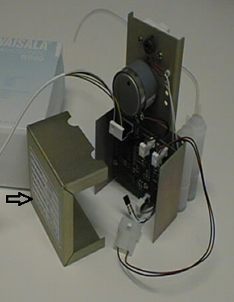
  - The two files needed for background current correction and pump efficiency should be already correct. The overall configuration should look like this:
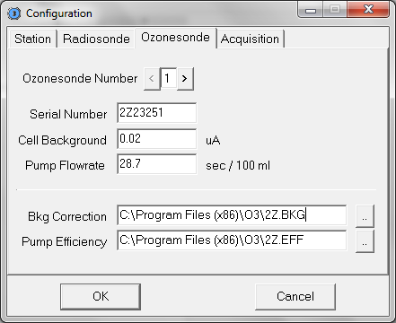
  - Click on “Acquisition” and make sure you have the correct COM port (once more). We usually leave it as COM2, as we set the VSPE pair to be “COM1 <-> COM2”. Once more, the file should be already correct as this won’t be the first time setting that laptop for flight.
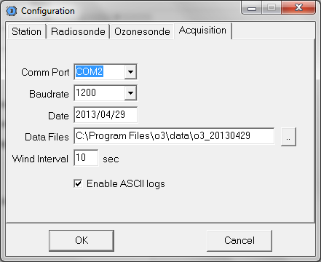
- Open a sound recorder program. We should have “Audacity” installed in the laptop. Record the signal the entire flight as a backup. The O3 and TrueTTY can decode the signal again from the recording in case there is any problems with TrueTTY or O3 during flight.
  - Save the file if you need to reboot it or if you are done recording. Save it as a .wav file. Do not save it as a lower quality recording. It won’t be decoded if you do so.

THINGS THAT MIGHT GO WRONG AND TROUBLESHOOTING
Really, anything could go wrong. I will try to describe problems we have encountered during my stay and how I solved them. Remember that TrueTTY uses the sound card of the laptop. Keep that in mind if things go weird. Also remember that signal-to-noise ratio is crucial to the O3 program and if it’s not high enough, it won’t work even if you can clearly hear the signal coming through the receiver and see it in the screen. Yes, it’s extremely sensitive.

- The signal appears to be “upside down” (visually) in the TrueTTY screen (and there is no signal going through O3) – this may happen all of a sudden, during transmission:
  - Restart TrueTTY.
  - If it doesn’t help, restart the computer. SAVE THE .WAV FILE FIRST!!!
- Everything looks good, but there is no virtual LED light flashing in the screen of the O3 program for either the radiosonde or ozonesonde (or both):
  - Check the signal going through the TrueTTY screen (if not inverted or weird);
  - Check battery levels for the radiosonde and ozonesonde;
  - Check battery level of receiver (should be connected to power);
  - Check battery level of pre-amp;
  - We have had evaporative cooling happening during vaccum chamber tests. It never happened during a flight, but it’s a possibility. There won’t be any signal coming because the chemical cell will evaporate and leave a frozen solid behind. It’s a salt solution (potassium iodide solution).
  - Check ground antenna position;
  - If no signal at all, pray! We have lost the entire ozonesonde box before.
PREPARING THE GROUND ANTENNA
The ground system is composed of a yagi antenna that has a pre-amplifier connected to it, a receiver that attaches to the antenna via a coaxial cable, and a laptop (previously prepared for the ozonesonde system).

The receiver connects to the laptop via an audio cable that comes from the push-to-talk. The audio cable connects to the microphone input in the laptop. Dr. Sohl knows how to connect the preamp to the antenna and the antenna to the receiver, in case you are not familiar with it.

