Media Briefing Sheet, Winter Inversion Study, WSU Physics Department
All graphics can be extracted from this document in high resolution, they are made smaller for display.

Particulate Matter as measured by a calibrated Metone GT-526 particle counter.

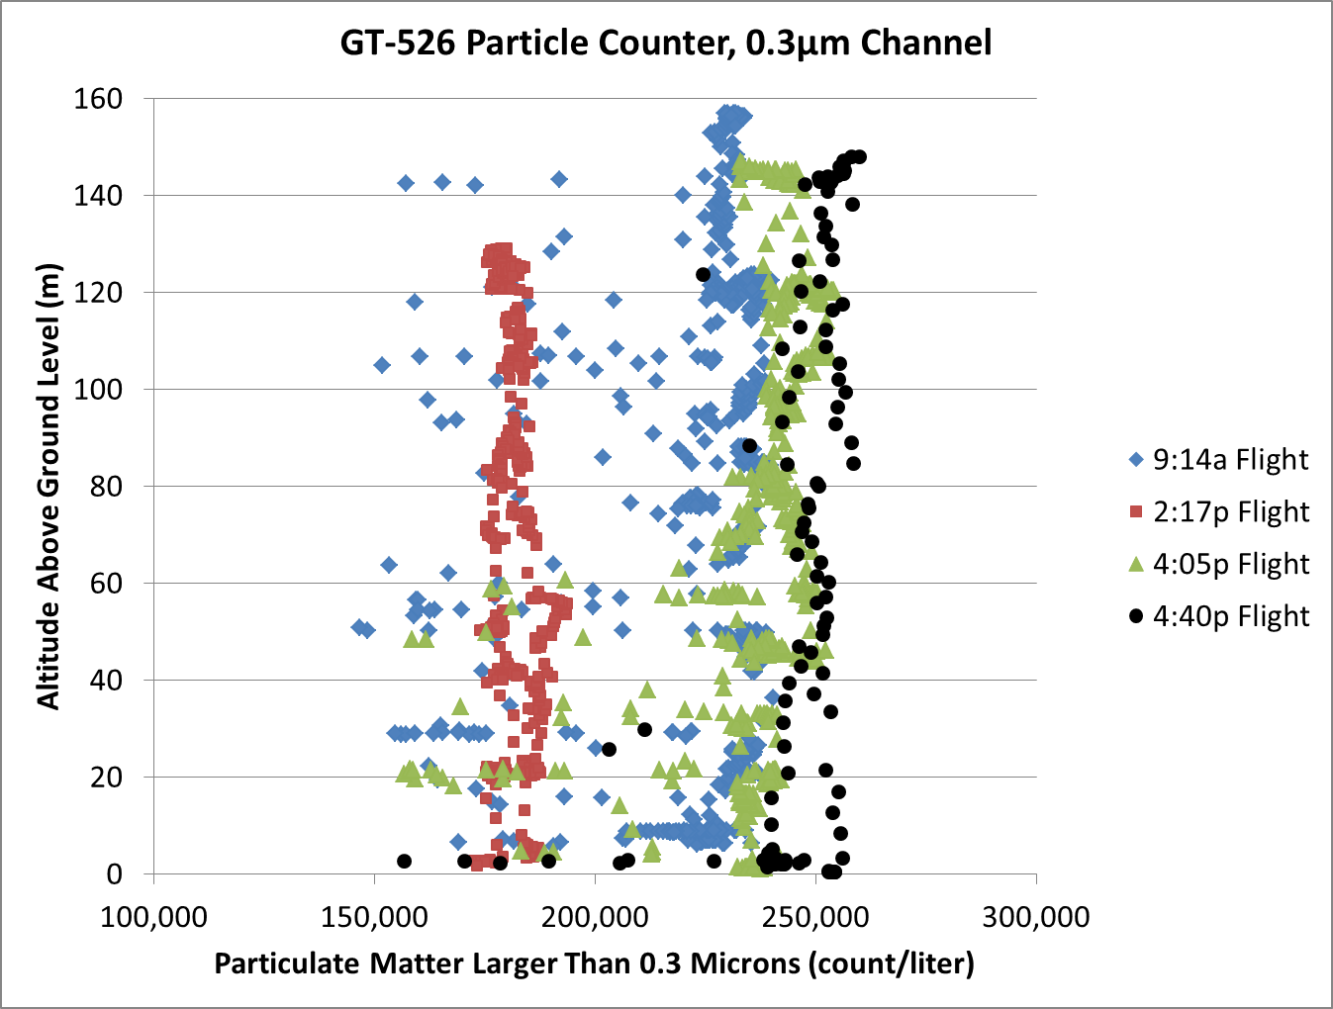

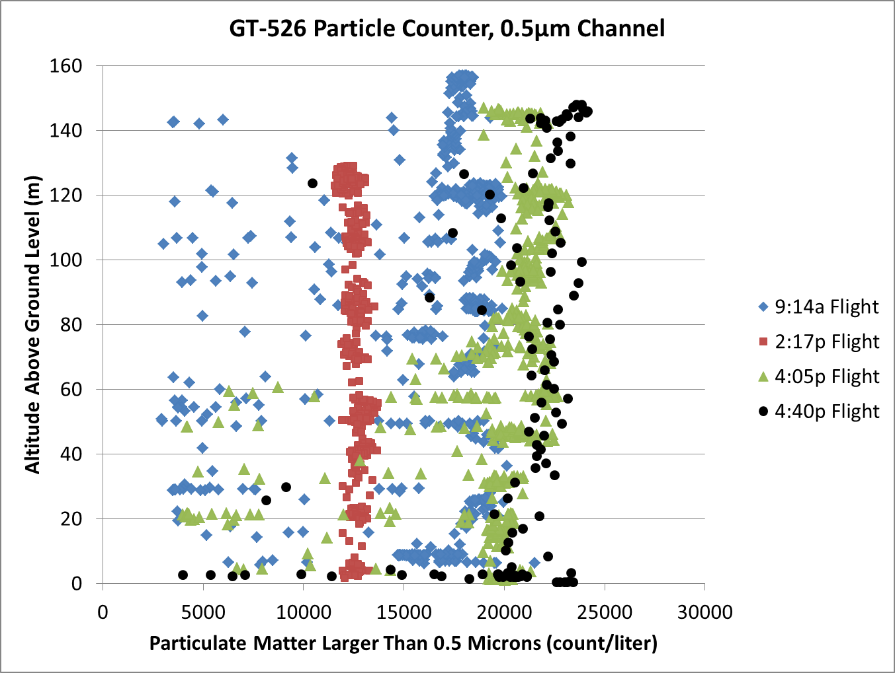

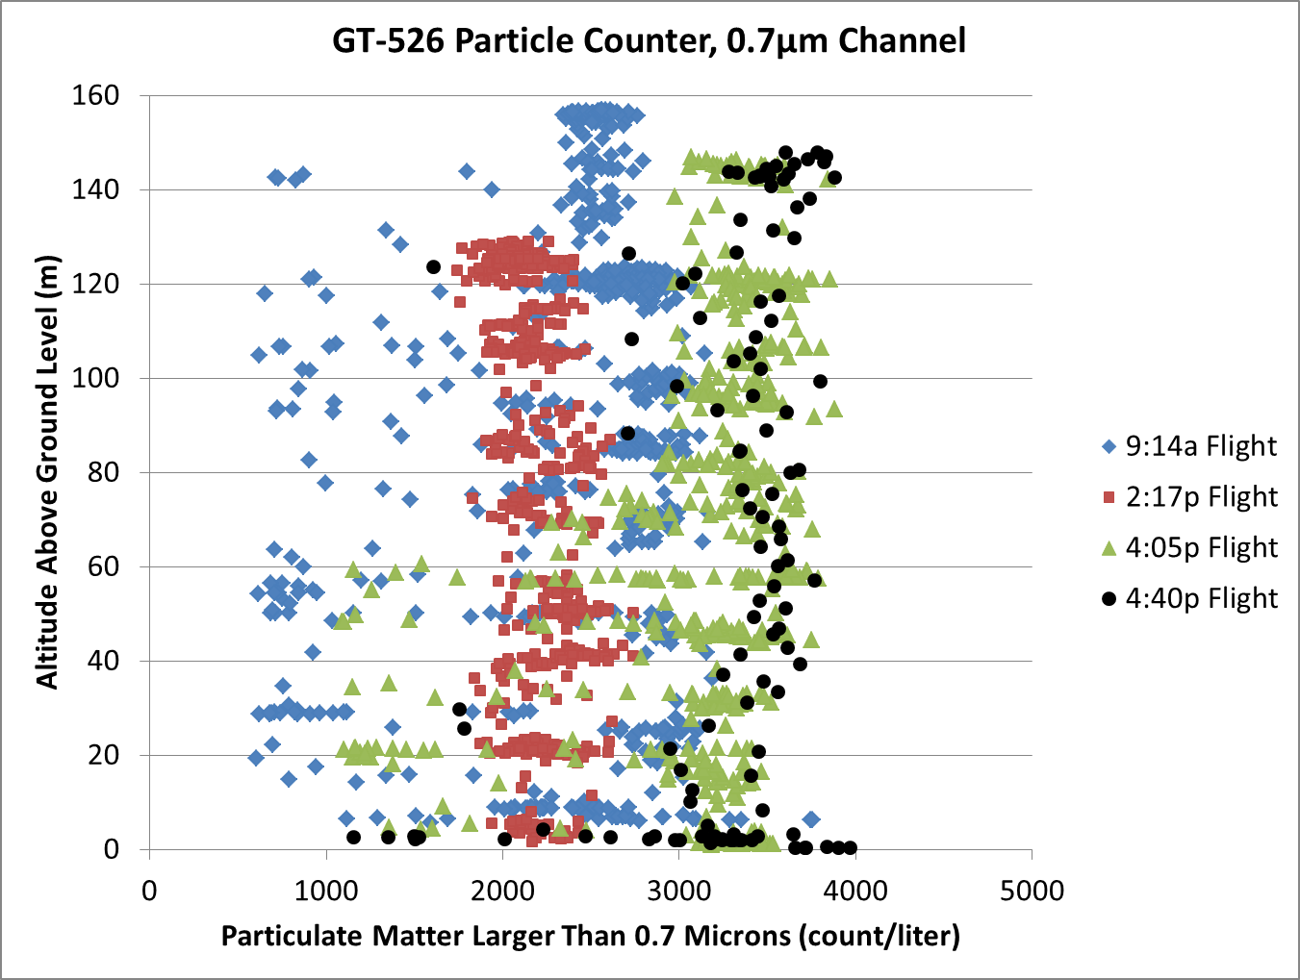

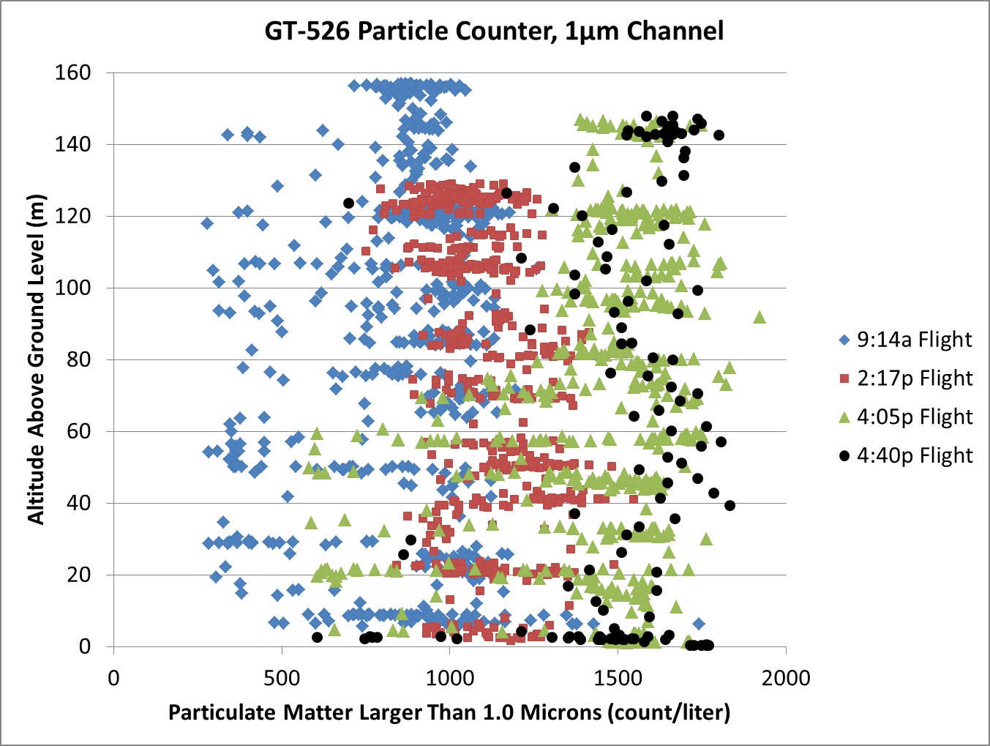

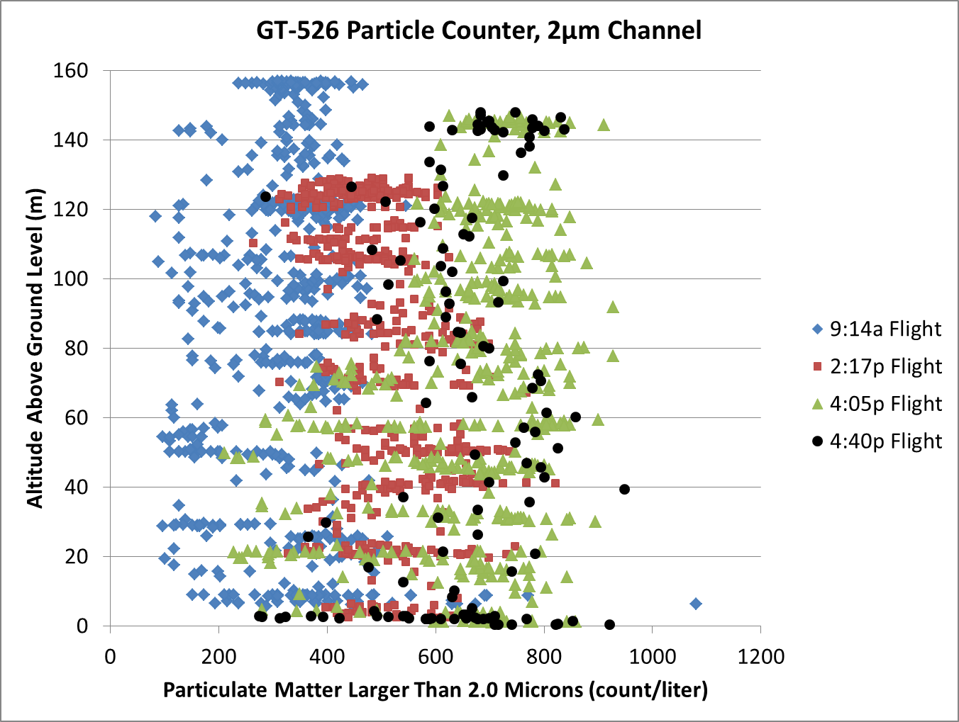

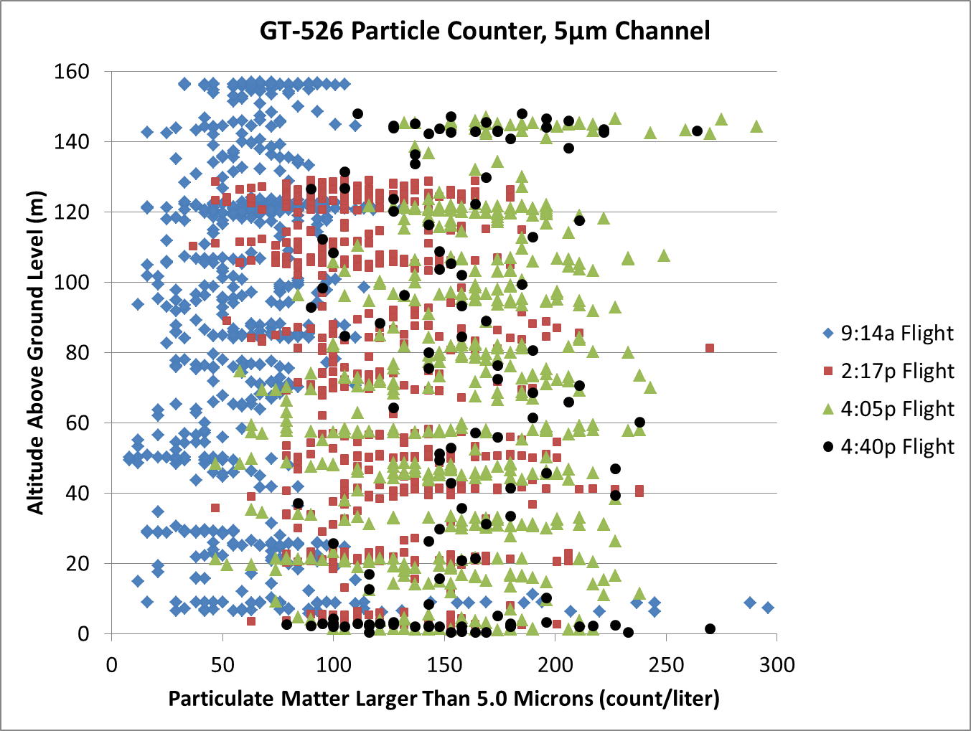

AtmoSniffer PM2.5 Particle Counter
This counts particulates in a fundamentally different way from the GT-526. For the AtmoSniffer there is a filter (impactor) at the frontend that removes all particles larger than a certain size. In this case the particles larger than 2.5μm in diameter are removed by the impactor. The AtmoSniffer then uses light scattering (in a similar way to the GT-526) to count everything that gets past the impactor. That is, the AtmoSniffer measures all particles smaller than 2.5μm.

The GT-526 has six channels. Each channel measures that size particle along with ALL particles that are that size and bigger than the listed size for that channel. Thus, the 2.0μm channel includes all counts for particles in both the 2 and 5μm channels.

With this in mind, you can see that the AtmoSniffer has results that are reasonably consistent with the GT-526 counter. Specifically there is more “noise” in the morning hours. The lowest count was the 2:17 pm flight then the number/amount of particulates increases as the afternoon evolves towards sunset.

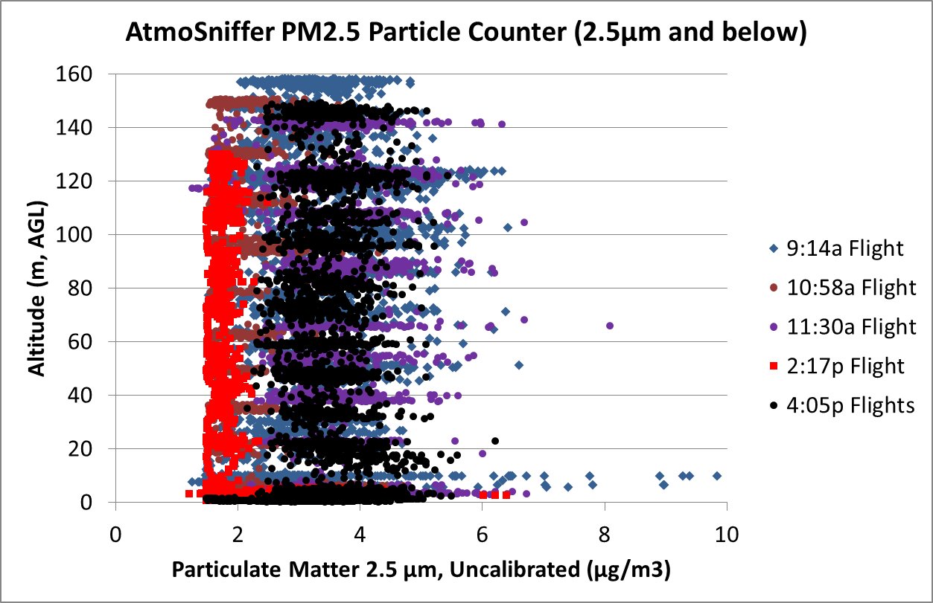

Ozone undergoes the well-known daily increase that follows the Sun: less in the morning, more mid-day, then less in the late afternoon. It is reasonably constant vertically.
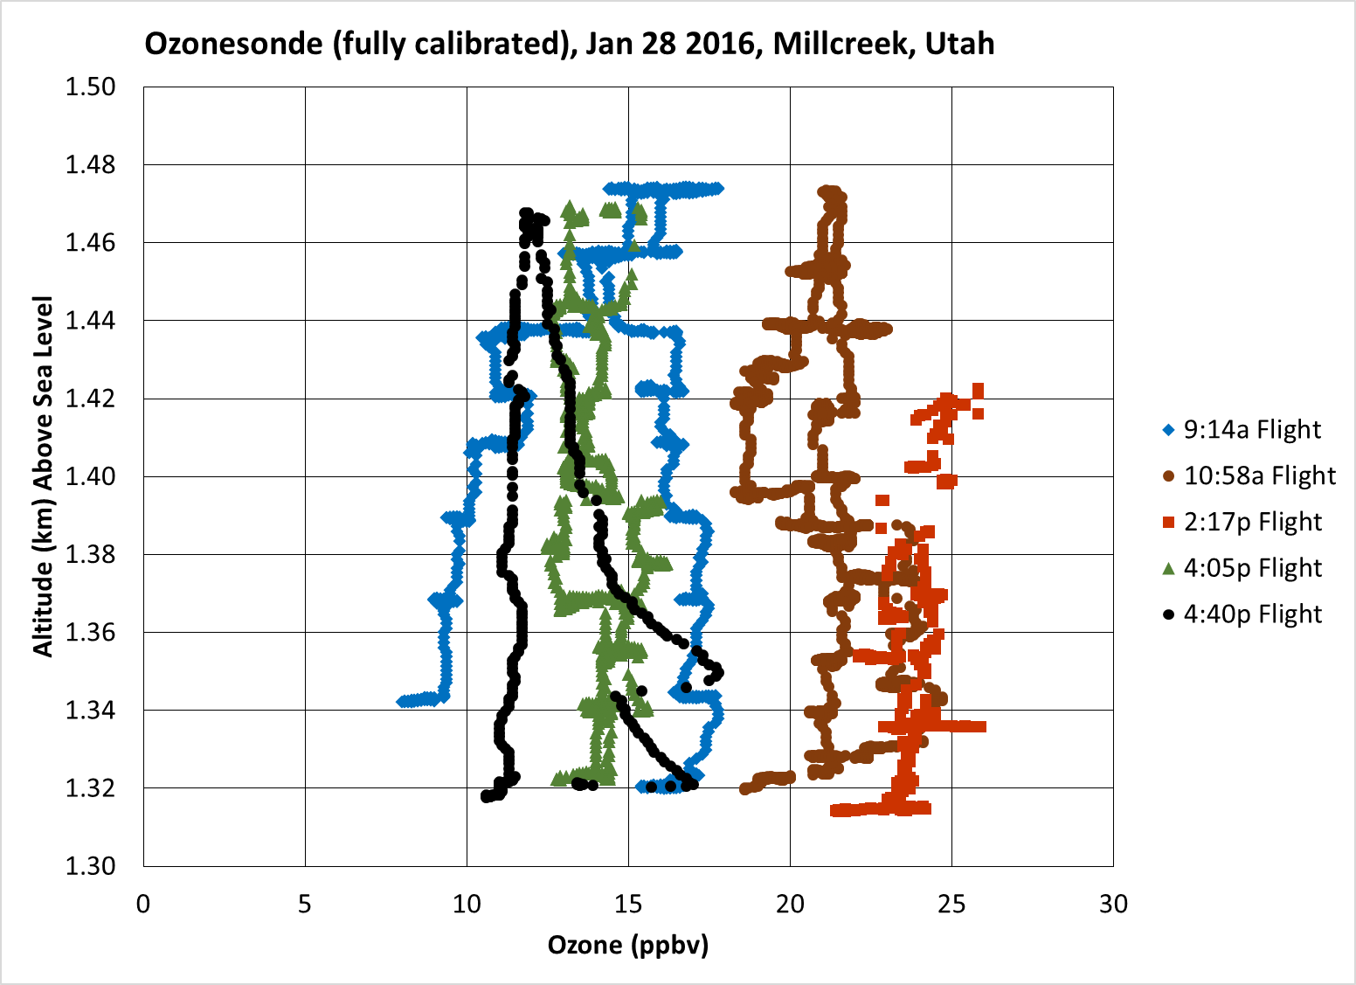

The sensor in the AtmoSniffer is an inverse sensor, i.e., lower the voltage = higher concentration. Note that the ozonesonde and the AtmoSniffer are in generally good agreement.
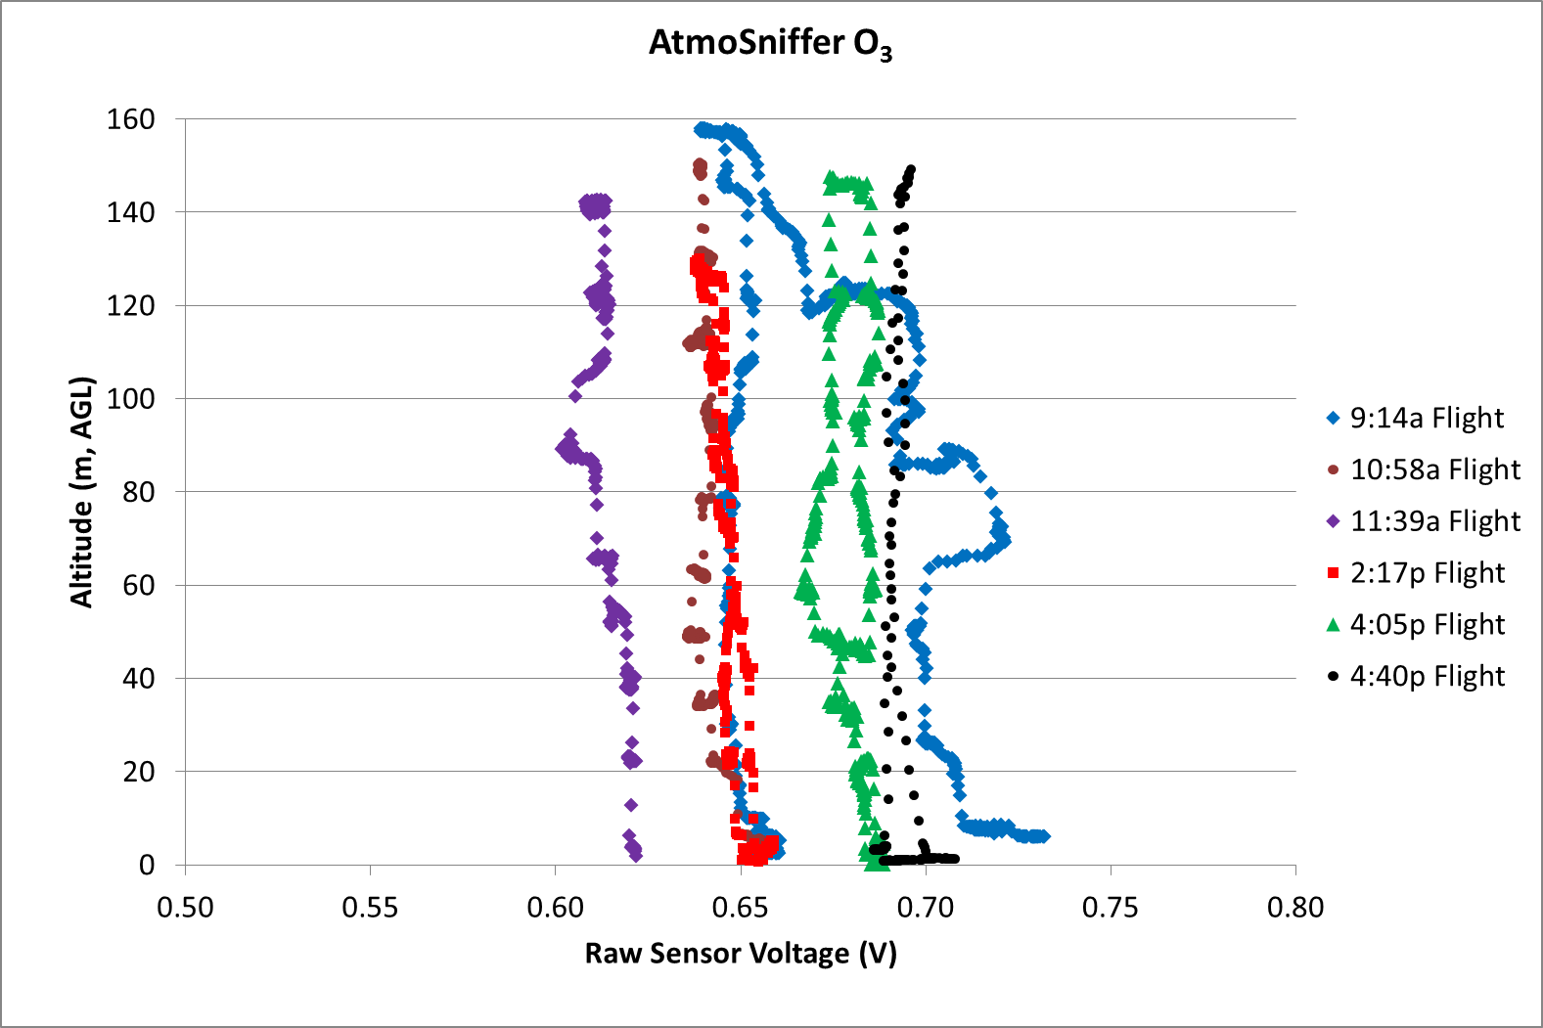

Ammonia
The ammonia levels do evolve over the day. Ammonia starts out reasonably uniform in the vertical column. In the middle of the day the levels change quite a bit with altitude and evolve in time. By late afternoon the ammonia levels become uniform again in the vertical profile.

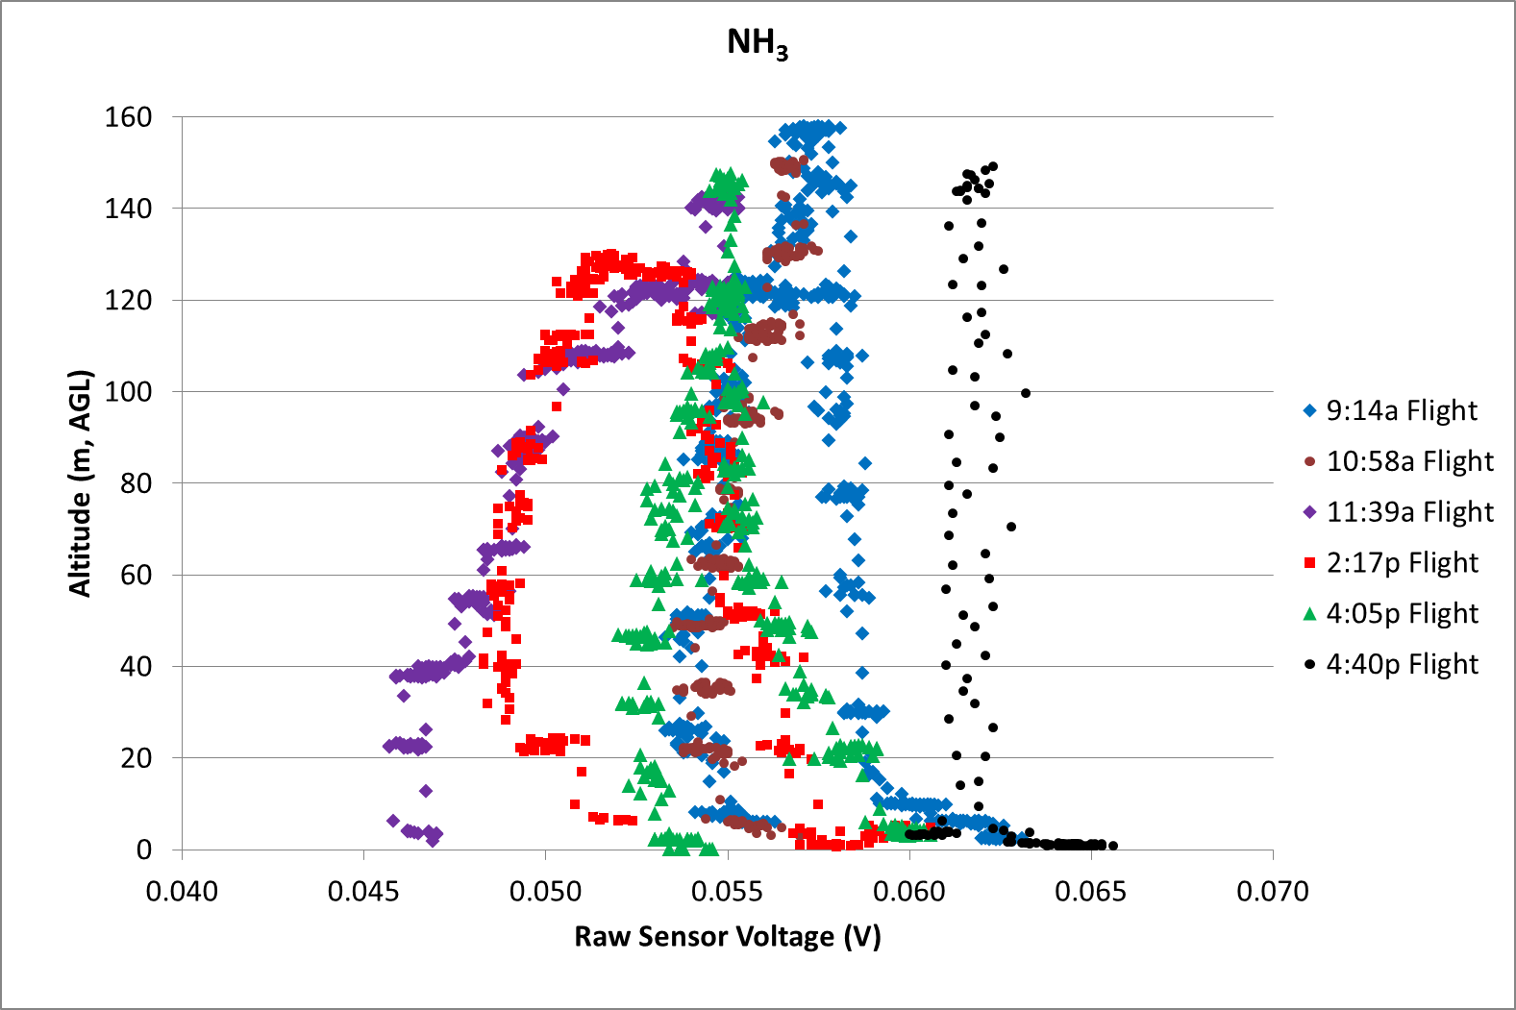

Nitrogen dioxide changes over the course of the day, but is reasonably uniform vertically at any one time. The main exception is the morning when the NO2 levels are changing the fastest.
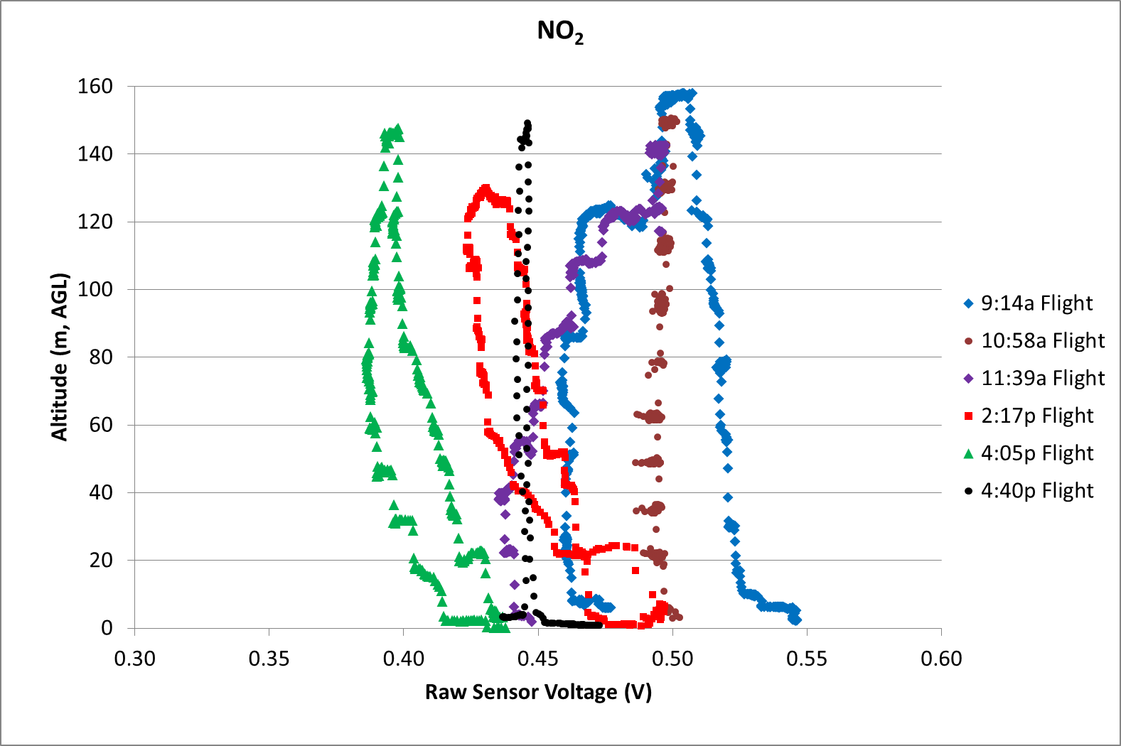

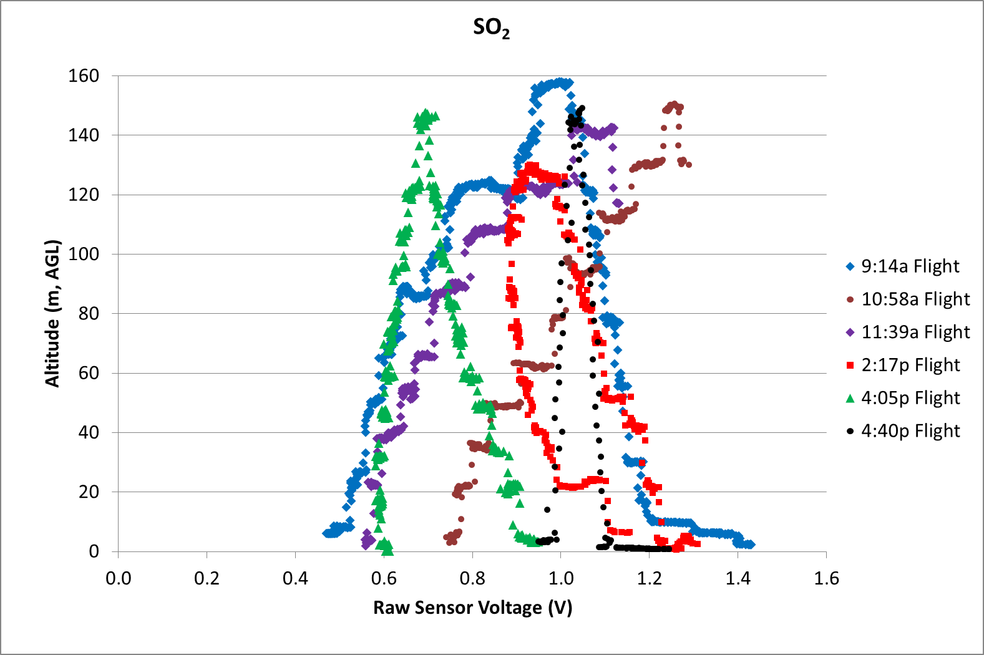
Sulfur dioxide seems to change with altitude in the mornings and becomes more stable in the afternoon.

The carbon monoxide readings look too symmetric for each flight. This makes me suspect of this sensor and that it needs more calibration. Here are the results from flight (again, smaller voltage = higher concentration):
