Flight predictions for late June 2021.
Predictions made Tuesday evening, June 22, 2021

There appears to be a high-pressure ridge that is parked above the Pacific Northwest that is pushing the jet stream to make our flights all run to the southwest. That doesn’t seem to move out until July 2nd or so. Even then, the ridge is pushing us to the south.

June 25:
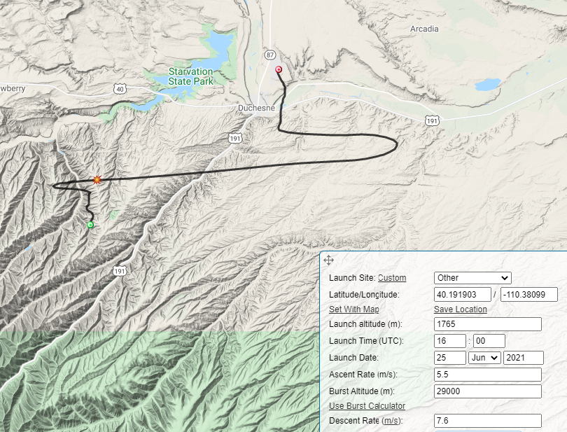

June 26
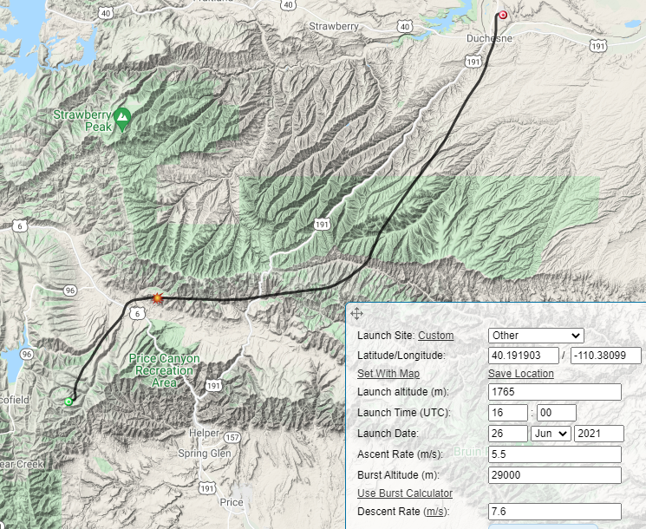

June 27
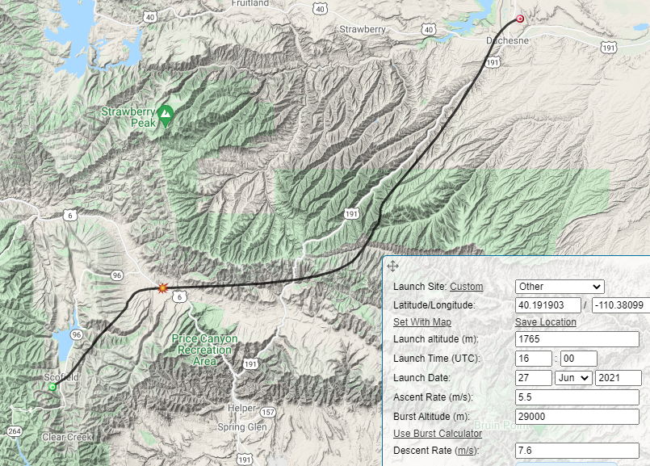

June 28
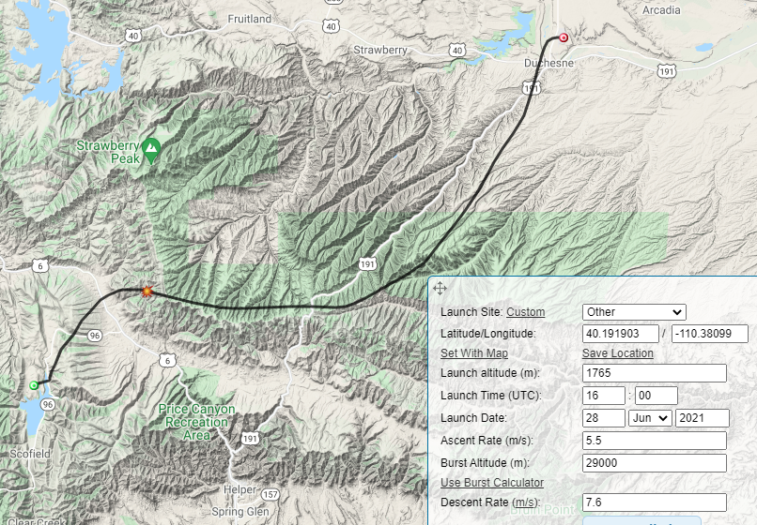

June 29
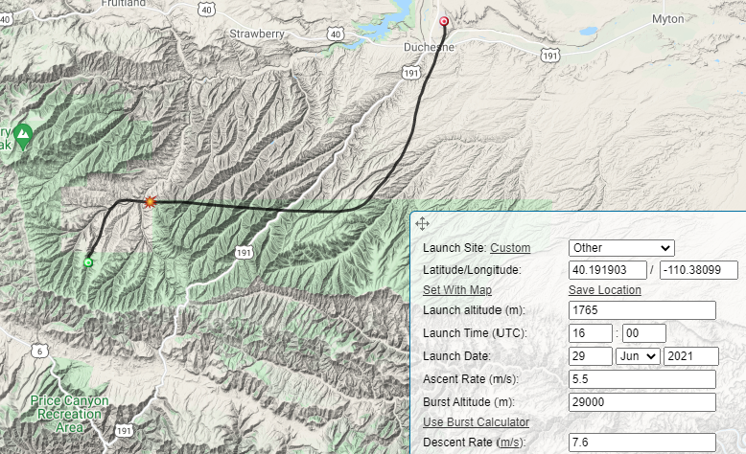

June 30
Too far in the future for the prediction software, for a 7 am launch on the 30th we get:
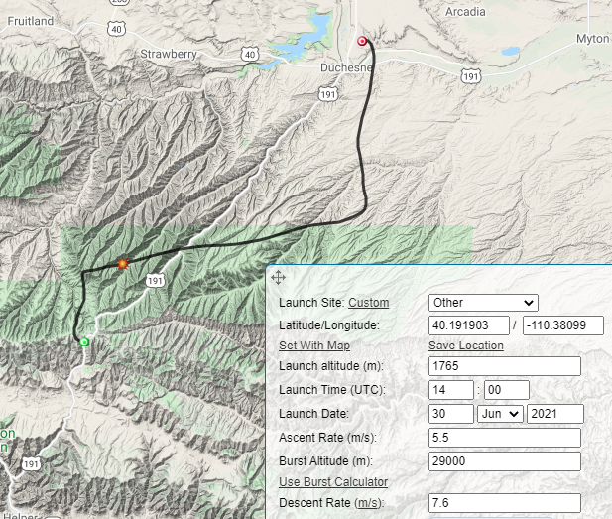

Jet Stream Predictions Using the GFS Models
