Flight predictions for June 30-July 5, 2021.
Predictions made Sunday evening, June 27, 2021, 6pm-7pm

There is a series of high-pressure ridges that move in and northward first from Arizona then joined by one from Southern California. These ridges give us an extended flight window.

June 30:
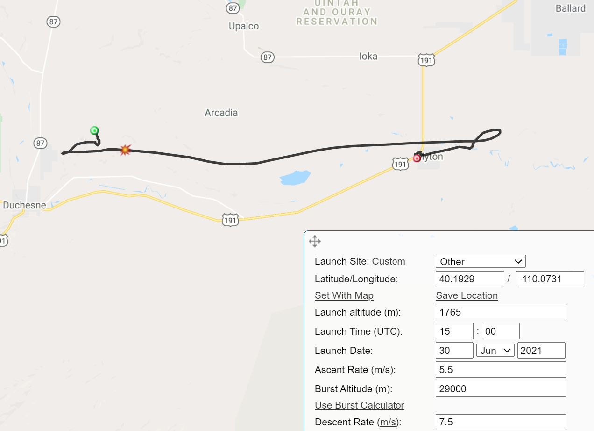

1:00 pm even works if we move, point is, the prediction window has plenty of wiggle room:
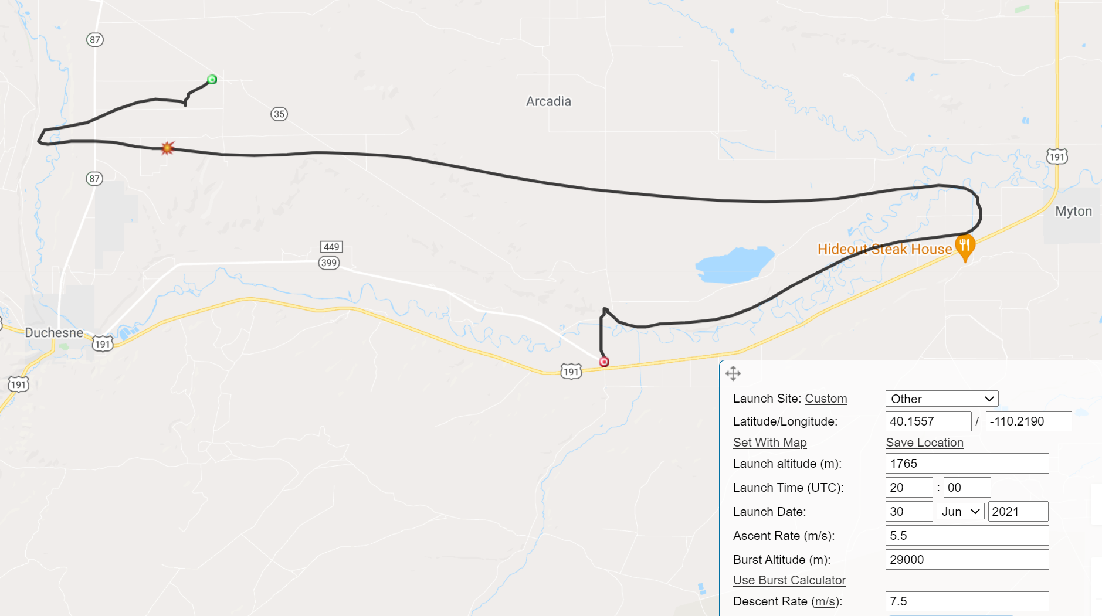

July 01
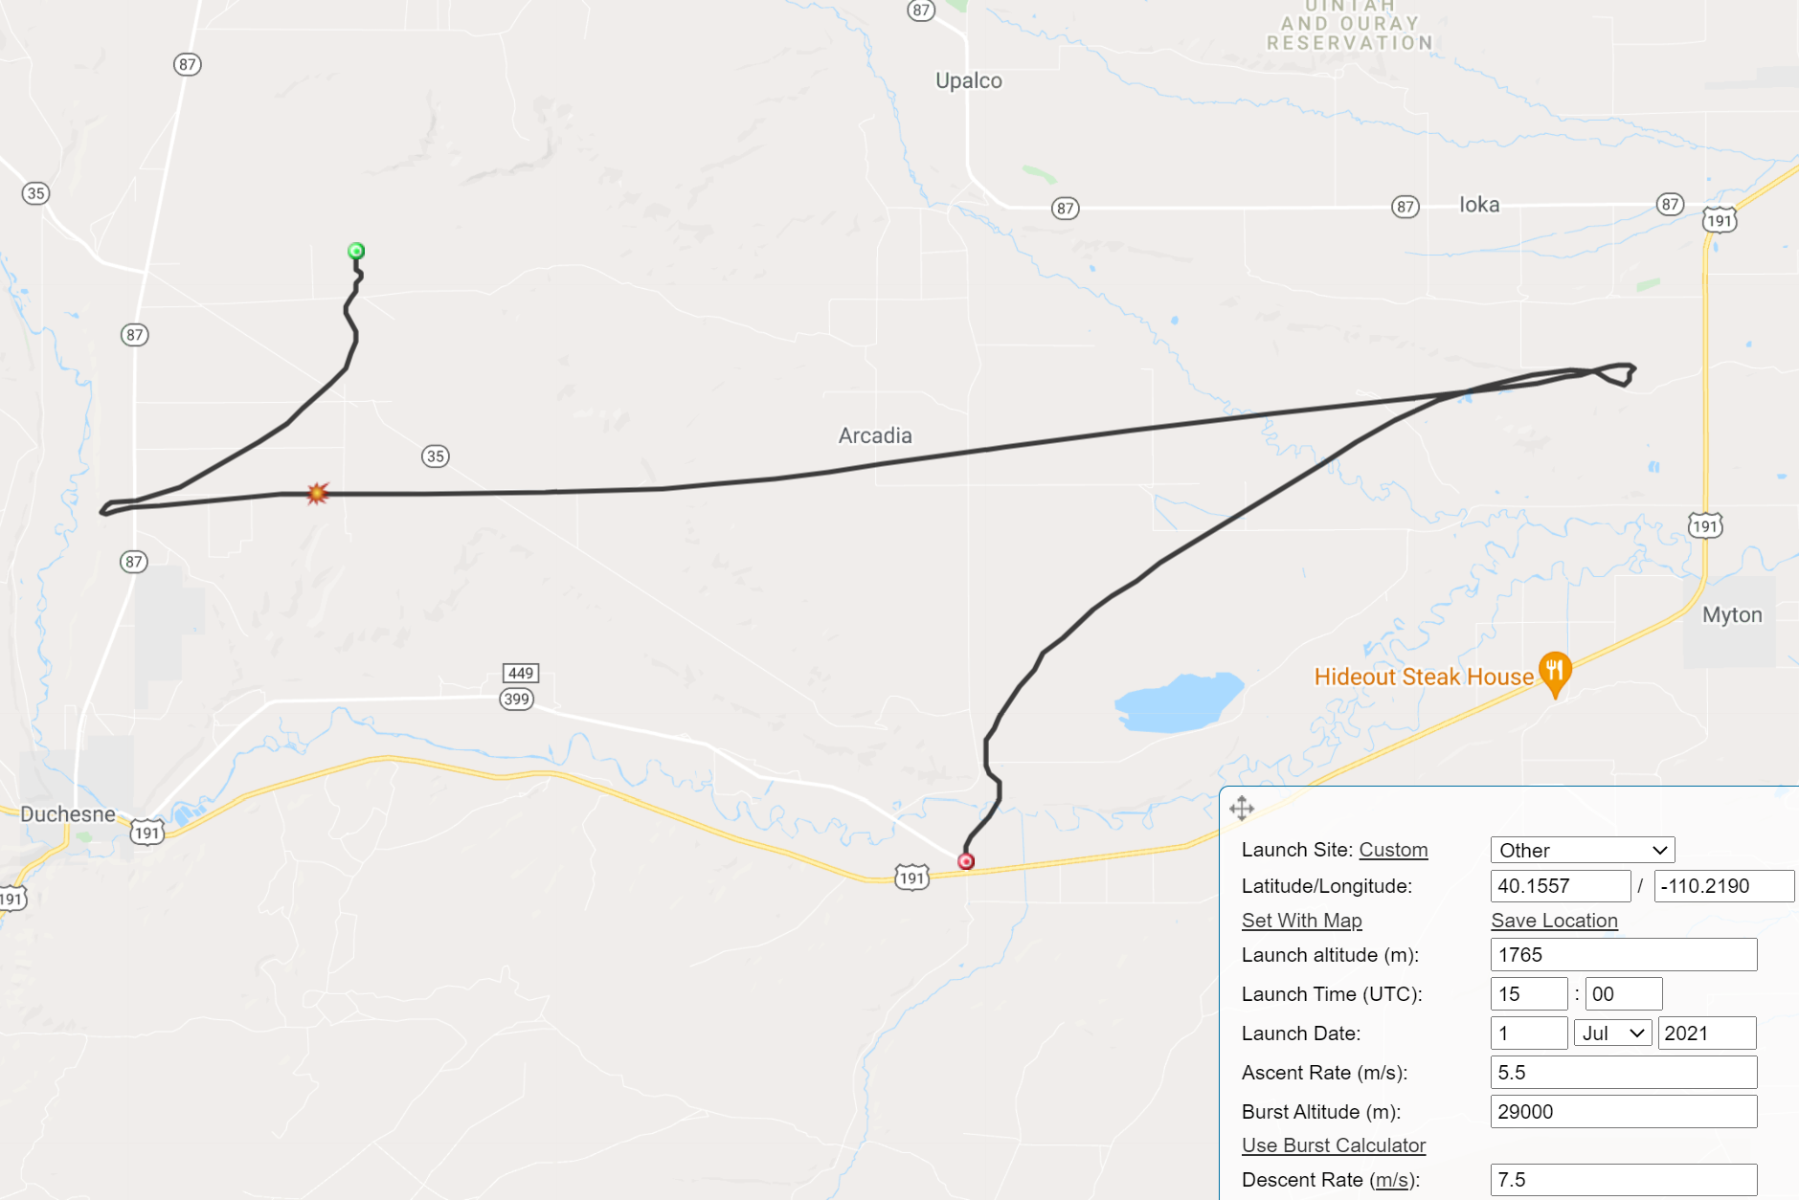

July 02
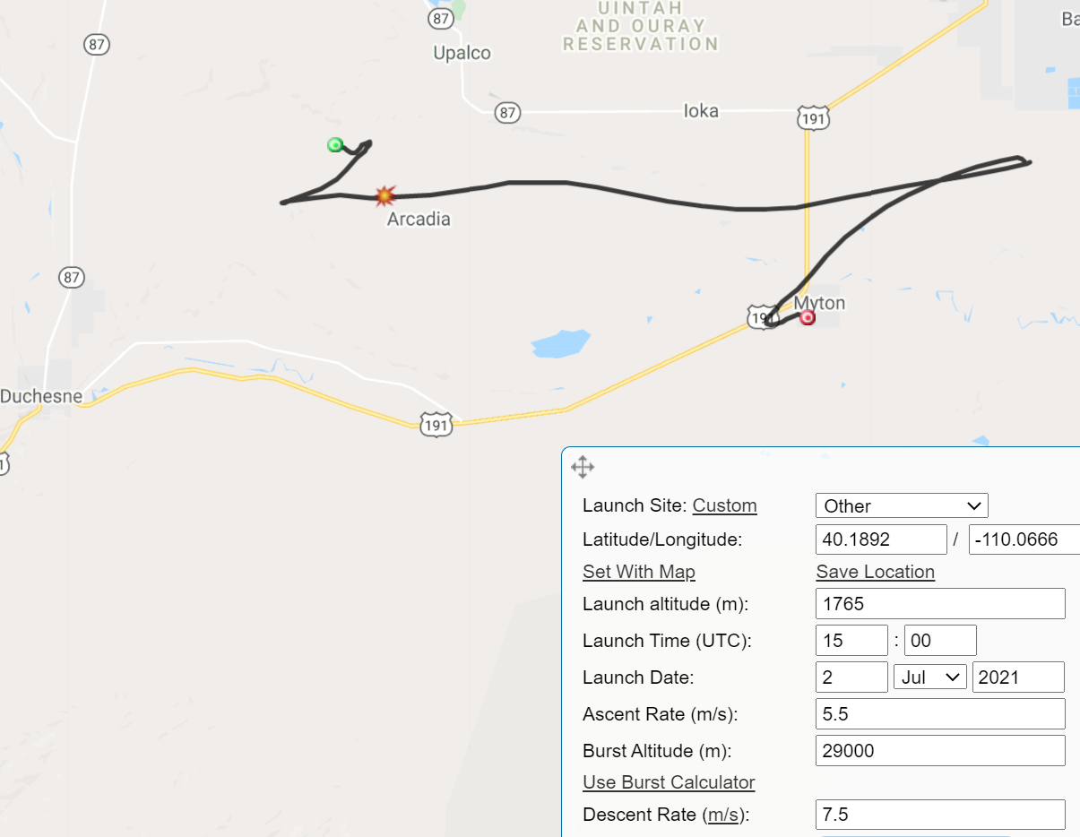
July 3, launching from the USU Roosevelt Campus:
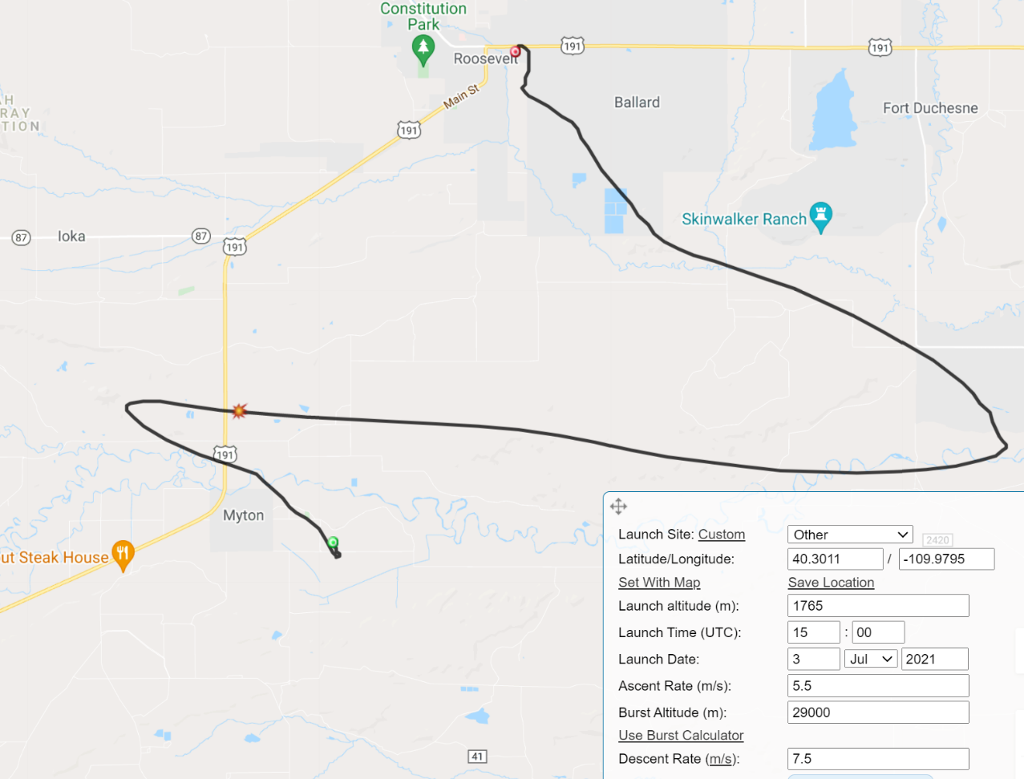
July 4 (gasp):
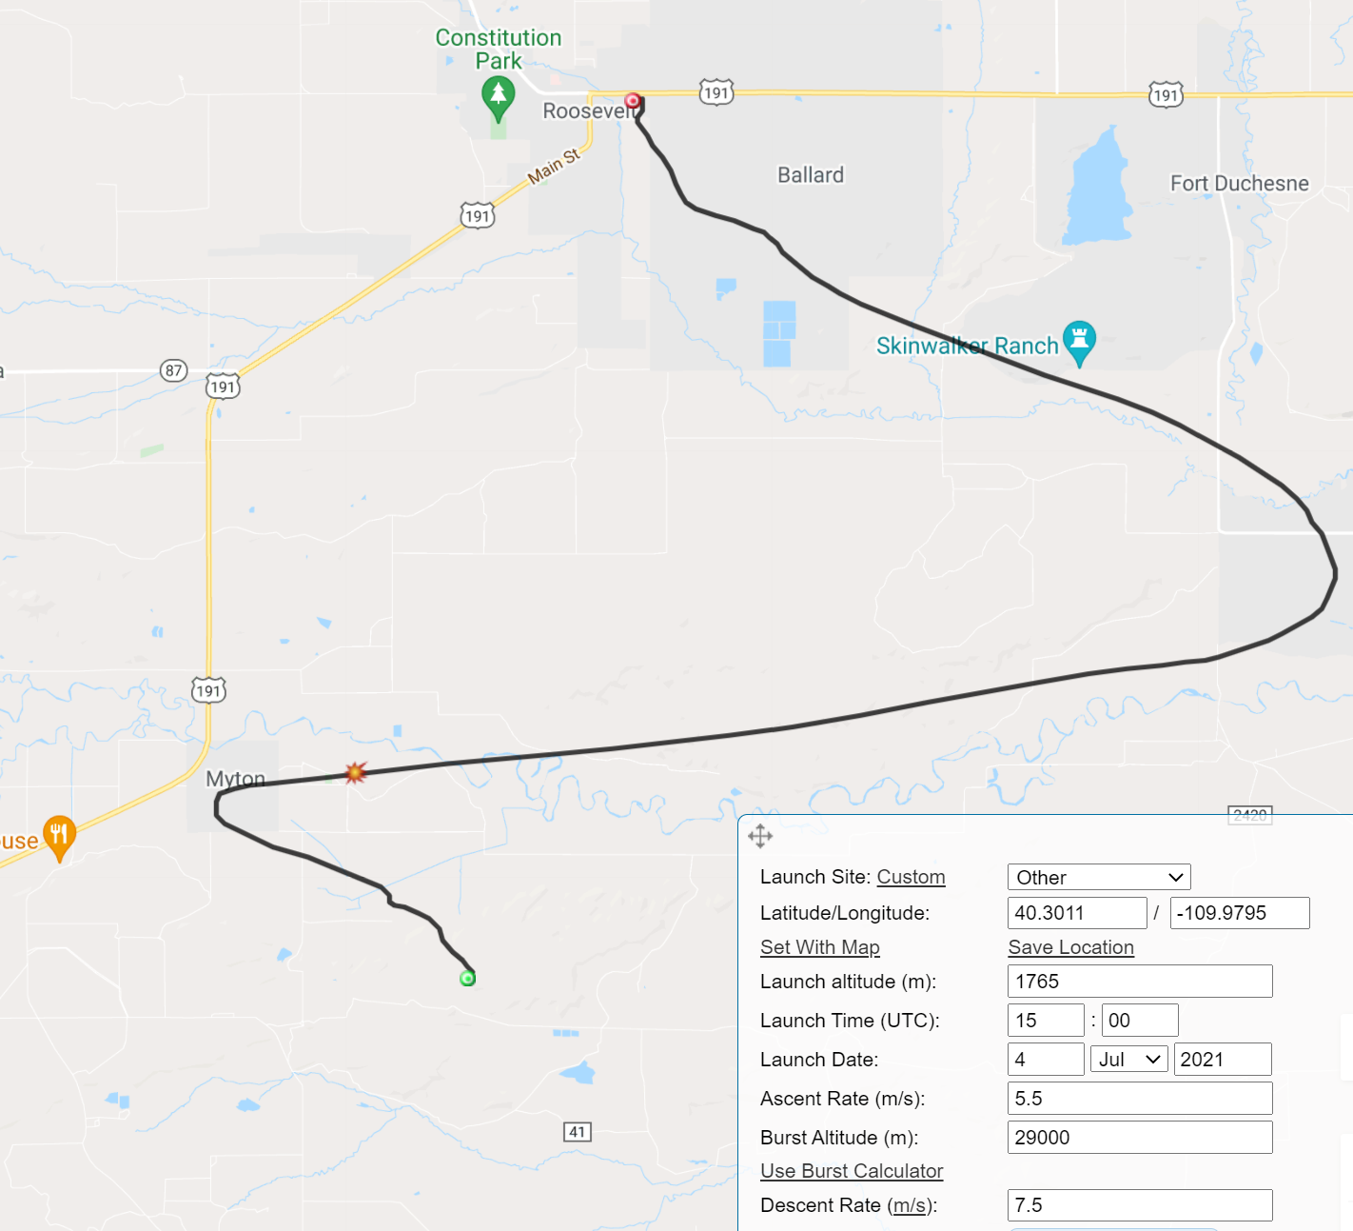

July 5 (okay, it is the 4am prediction, but still…)
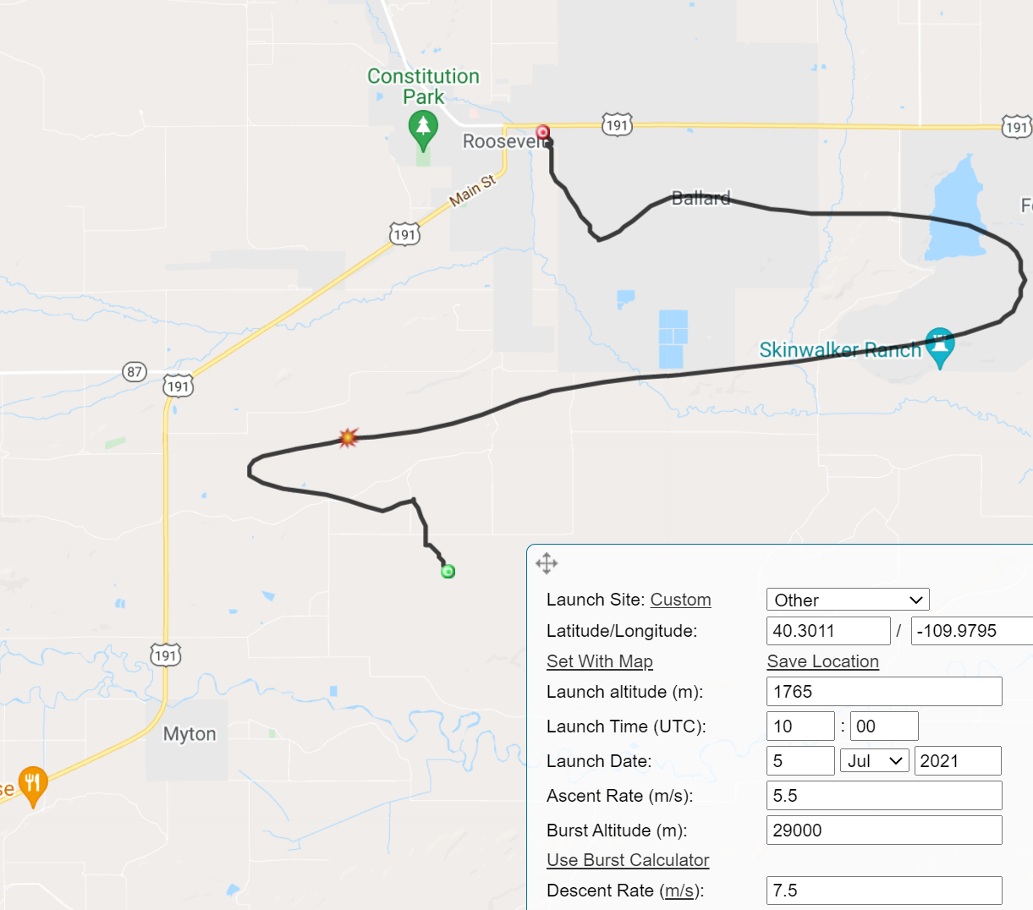

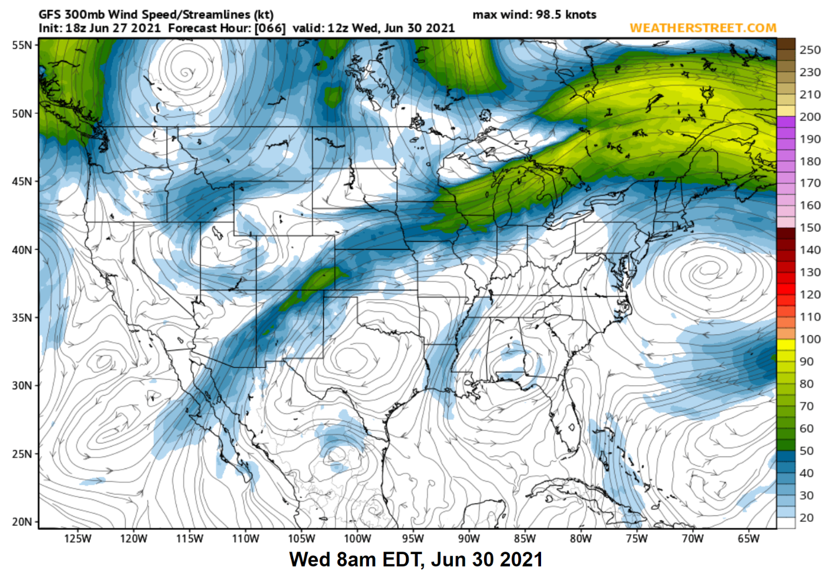
Jet Stream Predictions Using the GFS Models

