NOTAM for moored balloon (aerostat)
Weber State University HARBOR Aerostat Flight HARAero150201

For: Moored sounding balloon
Operation Dates: 2014 February 01 to 03
Operation Time: 12:00 - 18:00 MDT (19:00 - 01:00 Z)
Launching from: Burns Field, Evanston, WY, EVW:
Cruising Altitude: 100,000 feet
6. Time to reach 60,000 feet MSL: 55 minutes after launch.
7. Balloon Diameter: 5.5 feet
1. Length of suspension lines: 30 ft, total length: 40 ft
2. Payload weight: 10 lbs (5 modules < 3.0 lbs)
3. Helium fill, 3000-3500 PSI, 300 cubic feet
4. No trailing antenna
8. Flight Duration: ~100 minutes
9. Estimated time of impact: 11:00 - 16:00 MDT (17:00 - 22:00 Z)
10. Estimated location of impact: North of Green River, WY.
1. Location from EVW VOR: EVWr69/72nm
2. Location from Fort Bridger VOR: FBRr42/42nm
11. Predicted direction of flight: 69 degrees = NE
12. Predicted distance to be traveled: 83 statute miles
13. My information - name: John SOHL
14. My information - Institution: Weber State University
15. My information - Cell phone number: 801-476-0589
16. Current Flight Status - http://harbor.weber.edu

NOTAM (877) 487-6867
Salt Lake FAA Center 801-320-2565/2562
Details emailed to: Harris Hartzell (Harold.CTR.Hartzell@faa.gov )
and Adam Vetter (adam.vetter@faa.gov ), Marnie Escandon (marnie.escandon@faa.gov )
Contact during flight: FAA Mission Control 801-320-2562, Area B.

I have submitted a NOTAM for Saturday:
EVW EVANSTON-UINTA COUNTY BURNS FIELD
!EVW 10/002 EVW AIRSPACE HIGH ALT BALLOON EVW SFC-FL600 NORTHEASTBOUND 1410251500-1410252200

Below are two different methods of predicting the flight. The flight tracks vary based on the forecasting methods. The flight predictor software packages are using two different NOAA winds aloft models.
Weber State University, Physics Department Prediction Software:
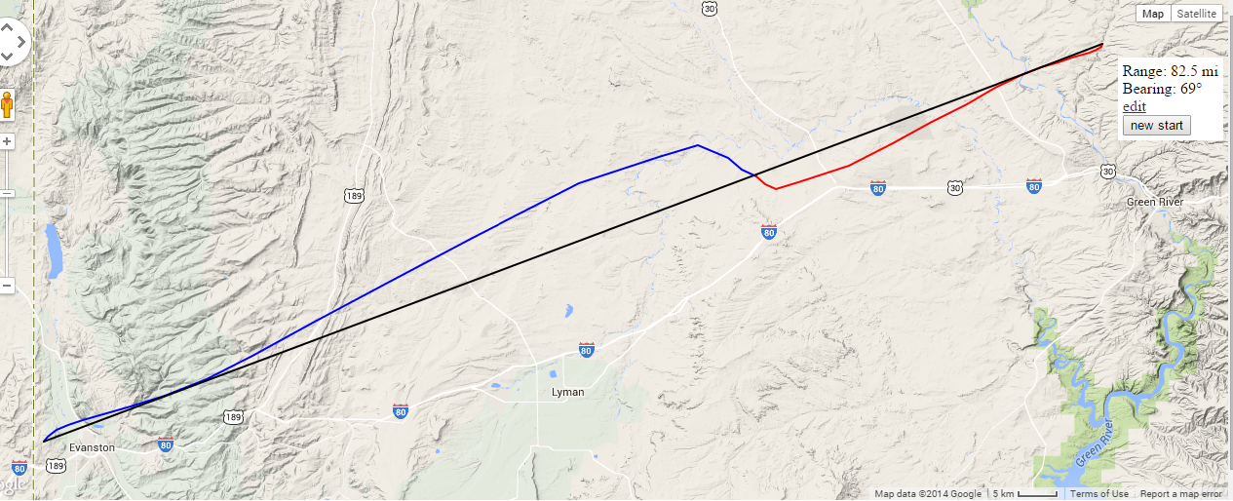

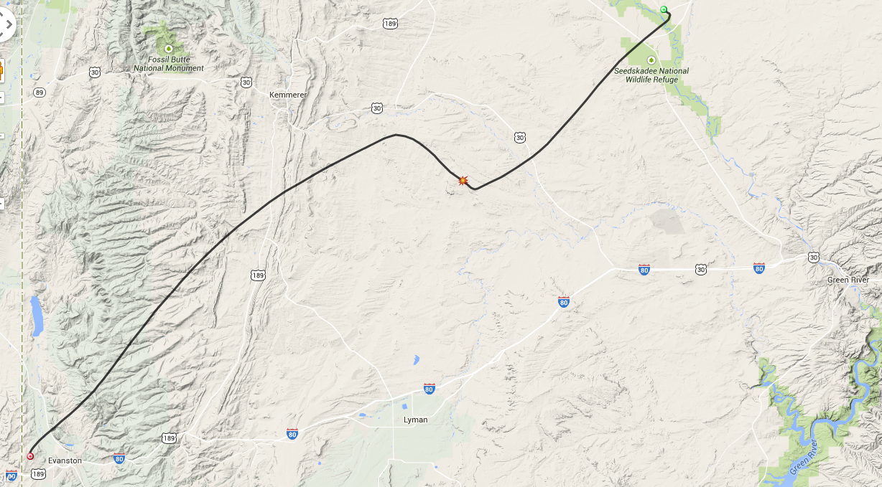
UK High Altitude Society (Cambridge, England) Flight Predictor:

Red dot is the launch point; the sunburst is the predicted burst location at altitude. The green dot is the predicted landing.

