Weber State Univ. Atmospheric Measurement Instrumentation

Tethersonde
A tethersonde is a measurement probe suspended below an aerostat (a balloon with a skirt-like wing that is moored to the ground with a tether wound on a winch). The Weber State University tethersonde is actually three instruments: A standard NOAA ozonesonde, a standard National Weather Service radiosonde, and a student-made sensor called the AtmoSniffer. The ozonesonde is an electro-chemical cell that creates an electric current based on the number of ozone molecules in contact with the fluid inside the cell. The radiosonde measures position, temperature, and pressure. The radiosonde radios the measurements from both the ozonesonde and the radiosonde back to a ground-based tracking antenna. The AtmoSniffer is not as sensitive as the ozonesonde, but measures much more: ozone, nitrogen dioxide, sulfur dioxide, carbon monoxide, ammonia, and PM2.5 particulates.

The tethersonde’s maximum altitude is defined by a combination of the payload weight, and the length and weight of the Dyneema mooring line. We are also regulated by the FAA who has set a legal operating altitude of 500 feet above ground, actual flights depart from this limit slightly due to changes in wind that are beyond our control. Our tethersonde systems have a practical maximum payload of 5 pounds and 10 pounds (2.3 and 4.5 kg) depending on which aerostat we select.

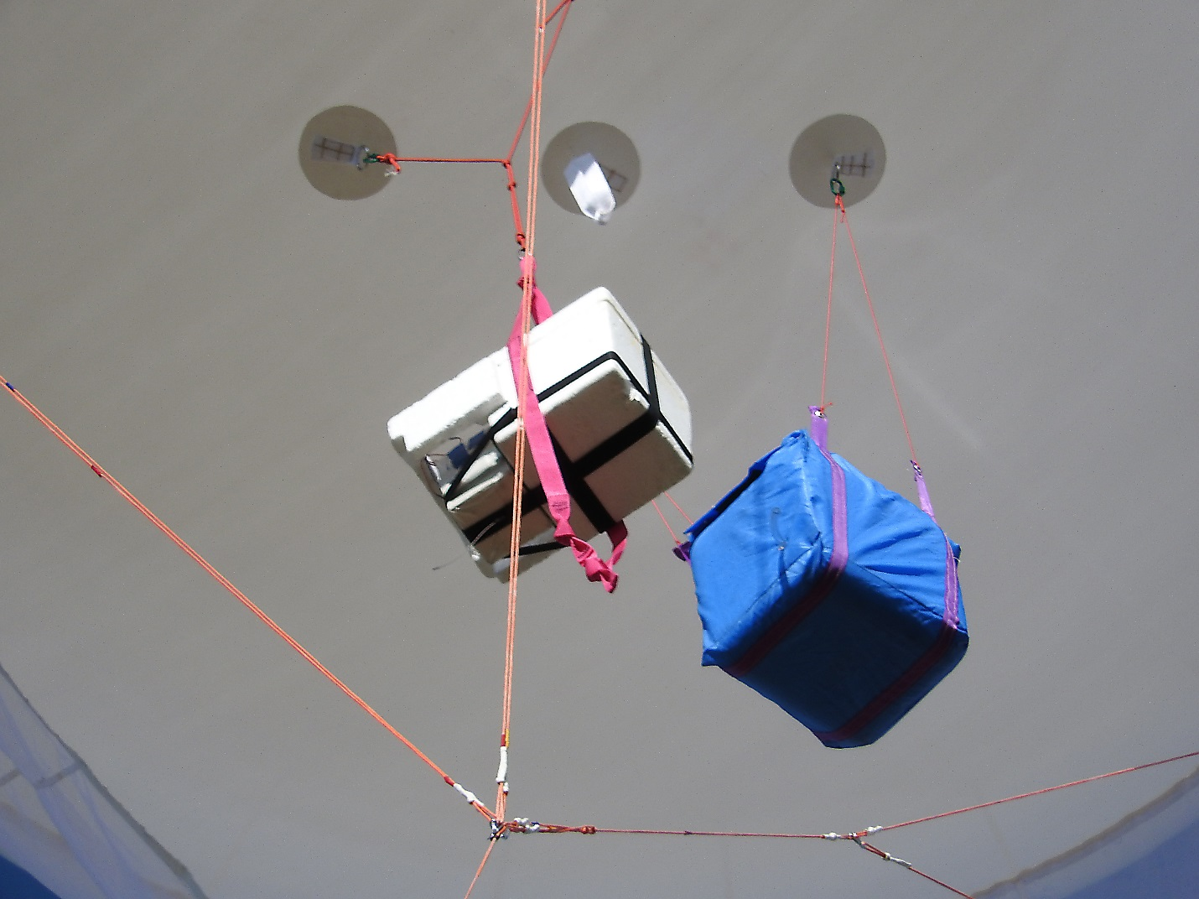
The sensor packages under the aerostat.

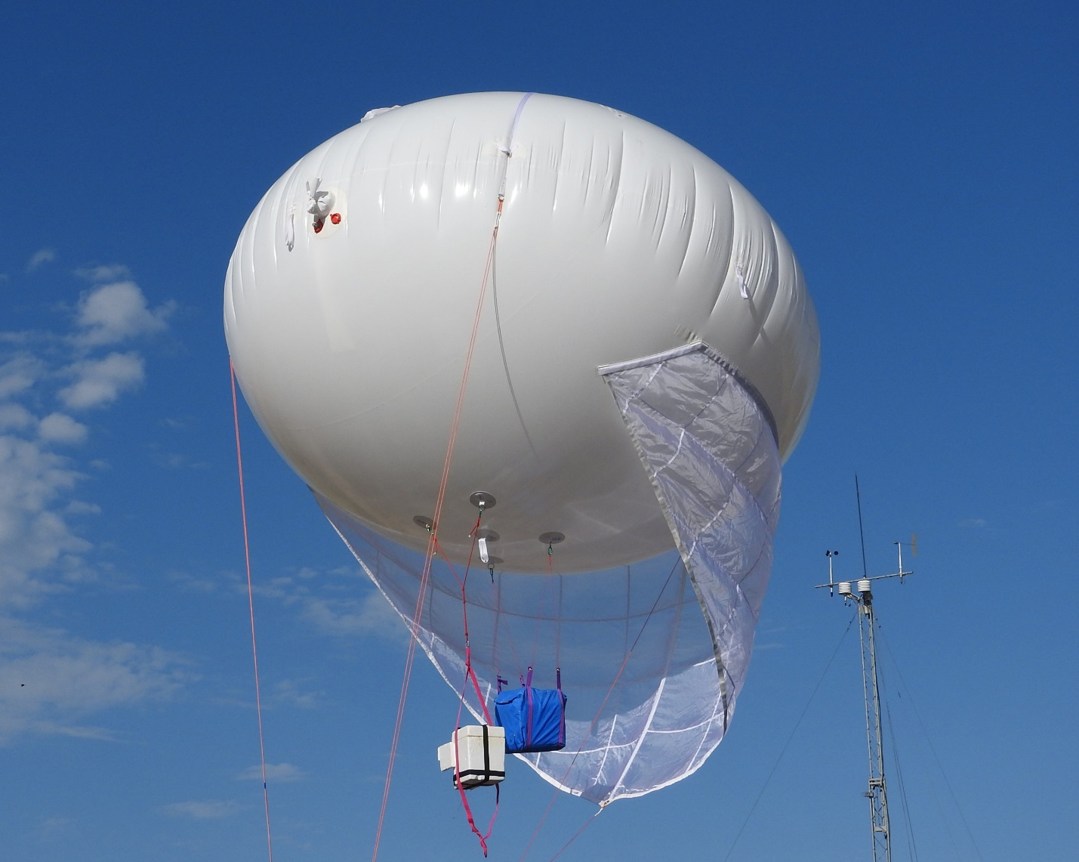
The tethersonde assembly showing the sonde packages under the aerostat with a Utah Division of Air Quality ground-based air monitoring tower in the background.

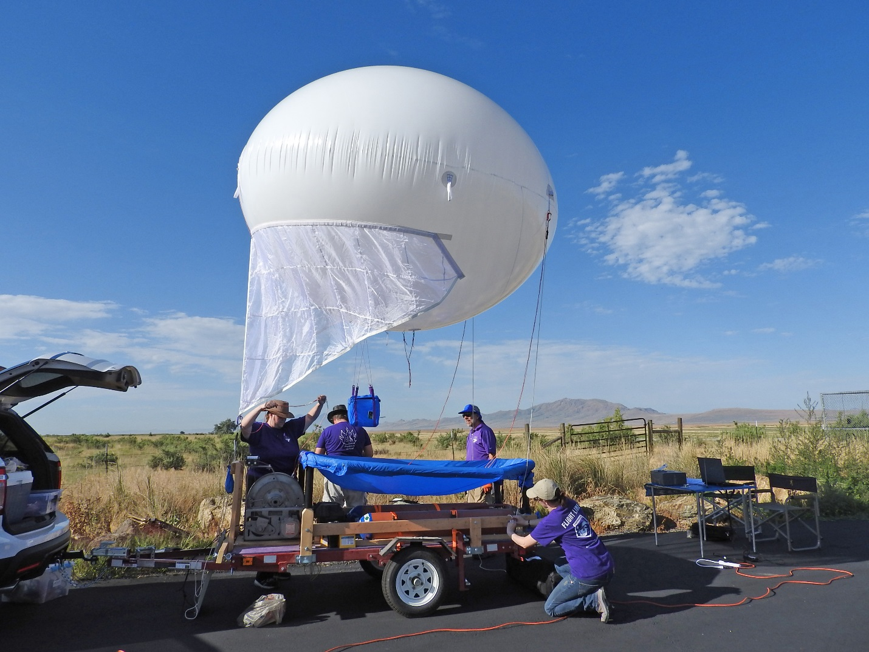
The entire tethersonde system showing the support trailer with the mooring line winch on the front of the trailer.

AtmoSniffer
The AtmoSniffer measures multiple pollutant gases (ozone, nitrogen dioxide, sulfur dioxide, carbon monoxide, ammonia), standard air parameters (pressure, temperature, % relative humidity), and aerosols (PM2.5). It also measures local turbulence (9-axis accelerometer, gyroscope, and magnetometer) and position (GPS). The AtmoSniffer is a new device (submitted for patent in June) and has not been fully calibrated. However, the measurements are still useful for comparing changes in gas concentrations from one location to another.
A full measurement set is logged every three seconds. Currently the data are stored on-board but will soon be available by live WiFi.

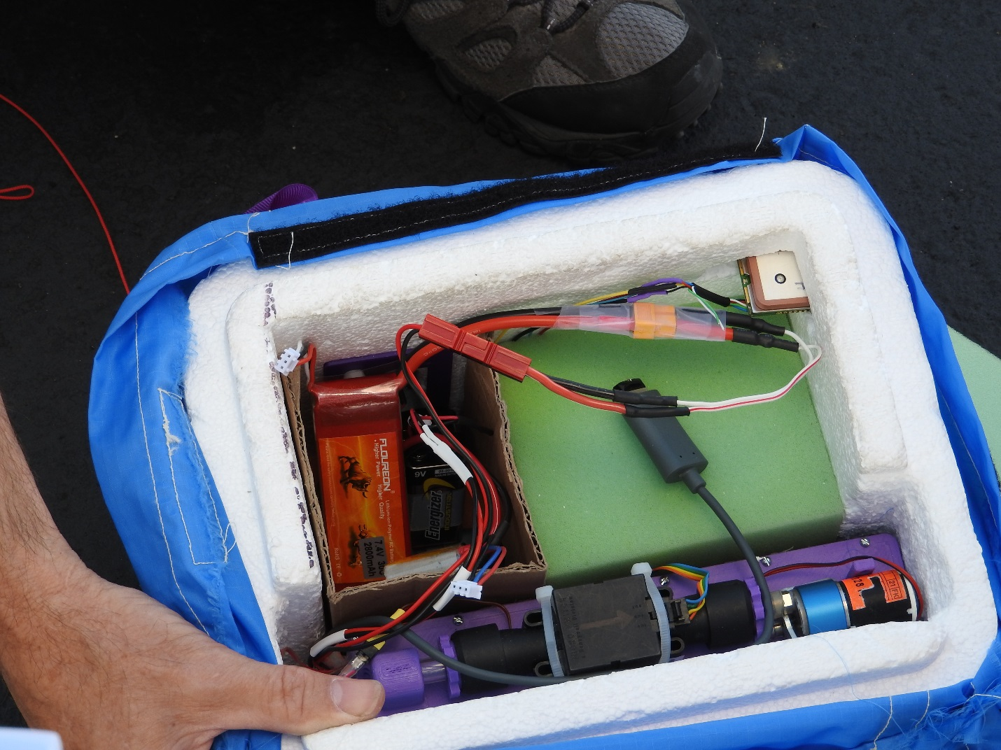
The AtmoSniffer and support equipment is mounted inside a foam protective box. This is version 1.0, the next version (1.1) is currently being constructed and will be significantly more compact.

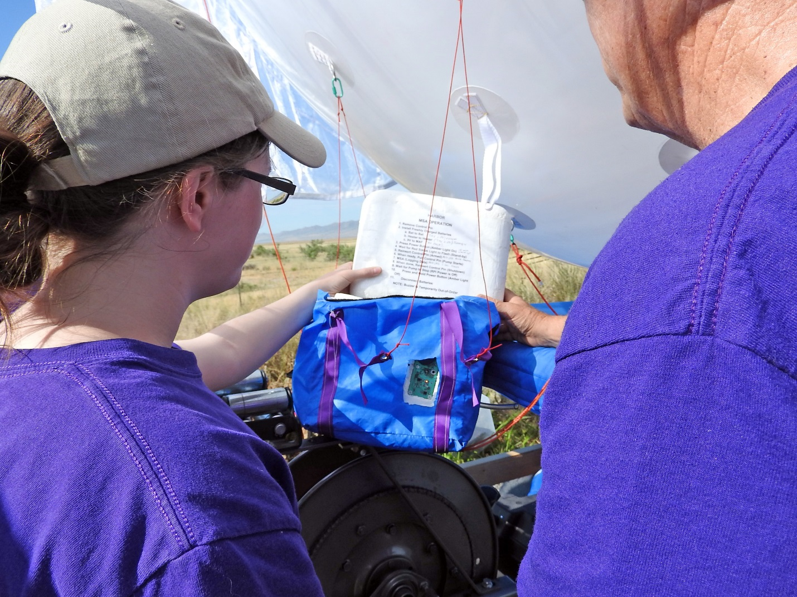
The AtmoSniffer is easy to control with a two button interface and directions printed on the lid of the box.

Great Salt Lake Summer Ozone Study (SO3S) 2015 measurement campaign
The tethersonde was collocated with a standard Utah Division of Air Quality ground-based monitoring station. Approximately once an hour from 8:00 a.m. until 9:00 p.m. the tethersonde was lofted from ground level to approximately 500 feet (150m) above ground-level, it dwelled at maximum altitude for 5 minutes then was brought back to ground. This provided a temporal set of vertical profiles of ozone and the gases measured by the AtmoSniffer.
Preliminary results showed reasonably uniform mixing of the air for most of the day and a time dependence that is very similar to what is measured by the ground-based air monitoring stations. Early morning measurements show differences in ozone concentration with altitude showing the lack of mixing early in the day.

Preliminary Data

The data for IOP2 are summarized in the following plot:
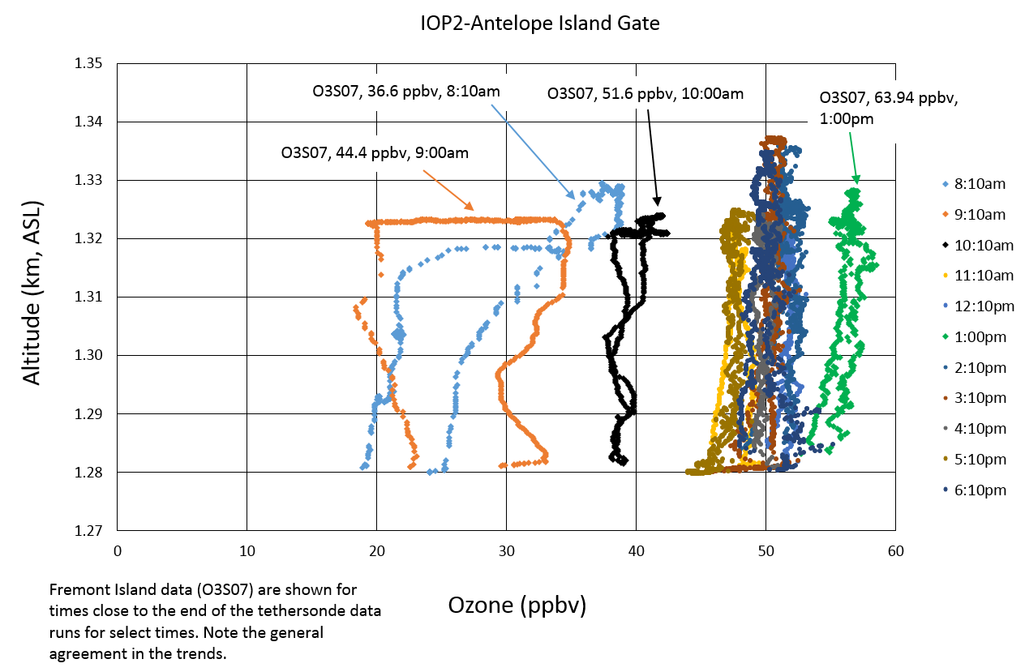

This figure has both the development of the ozone as measured by the tethersonde and the current readings from the 2B sensor at the lower Fremont Island location which is 10 miles away and surrounded by Great Salt Lake. Notice that there is significant variance in the ozone concentration relative to altitude in the morning as compared to the rest of the day. The 8:10 a.m. and the 9:00 a.m. data both start at the bottom left of the plots and evolve clockwise around the plot, clearly showing both temporal and spatial (altitude) evolution of the ozone in the morning. By 10:00 the atmosphere is becoming uniformly mixed.

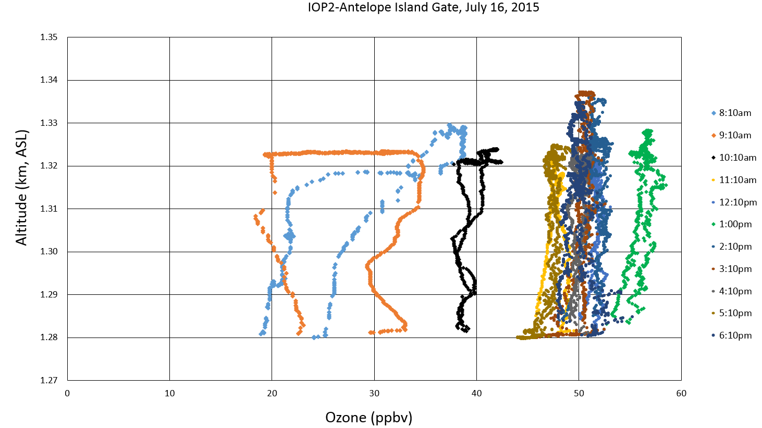
The next plot is the same plot but without the O3S07 Fremont Island data annotations.

NOTE: I’ll be adding AtmoSniffer data over the rest of Friday and Saturday morning.

