May 31 2015 Launch Location for mission HAR150531.
Al and John tracked down a nearly perfect launch area for us for Sunday. It is due north of the Duchesne airport. It is 13.2 miles by road from the airport turnoff from SR-87 to Mr. Garrett Sorenson’s home, our launch point. (14 min.)
Overview Map:
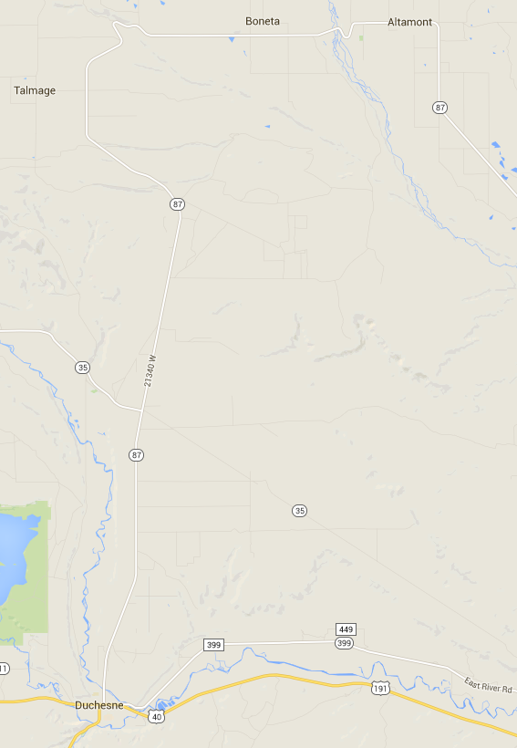
Duchesne Airport

Google Earth Closer View:
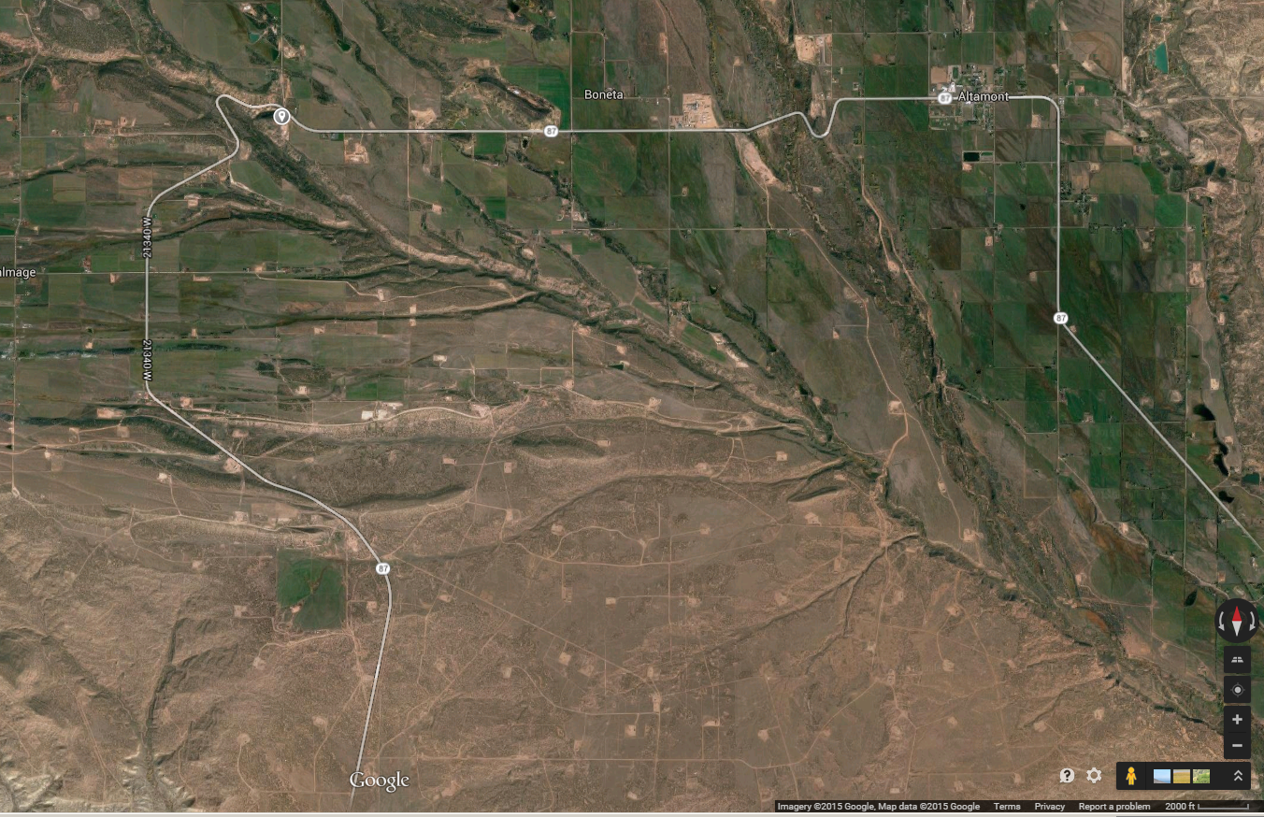

Zoom in to actual location:
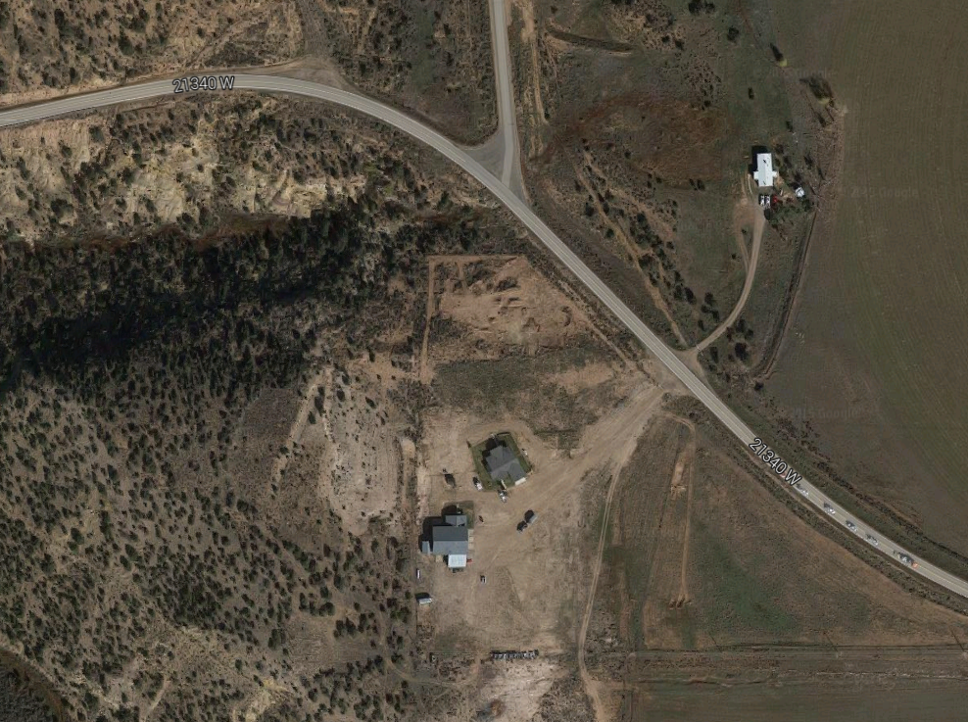
21000 W
Mr. Sorenson has graciously offered us full access to the entire flat area and his home!!

