Our first payload that has been lost.
Payload Mass: 2,243 g
Payload Weight: 4.94 lb
Total Mass: 2,786 g
Total Weight: 6.14 lb
Balloon: 3000 grams, Balloon Date: July 2014
Helium

Fill Ballast Weight: 10.0 lb

Tank #1 Starting Pressure: 2800 psi; Ending Pressure: 0 psi
Line Length: 147 cm

Tank #2 Starting Pressure: N/A psi; Ending Pressure: psi
Mass: 131 grams

Total “psi used” 2800 Used one very full tank of helium.
Line Length: 420 cm

Cut Down System. Design/Type = Davis/Page

Parachute Description: medium sized white
Mass: 412 grams

Line Length: 142 cm

Payload #1 Description:
Mass 1: 1513 grams
1
MSA-4 with two controlled stereo cameras (ELHP100, SD780)
There was also a GoPro Hero 3 Silver strapped to the underside
of the MSA-4. The stereo pair was on a 3-wood dowel frame.
Line Length: 156 cm
2
Masses: Modified MSA = 762g, Hero = 221g, Grey (ELPH) = 211g
Mass 2: grams
Black (SD) = 185g, Wood frame and foam = 134g
Line Length: cm

Payload #3 Description:
Mass 3: grams
3

Line Length: cm

Payload #4 Description:
Mass 4: grams
4

Line Length: cm
5
Payload #5 Description:
Mass 5: grams

Line Length: cm

SBATS call signs WB1SAR and KF7WII ; mass = 730 g
Mass: 730 grams

Launch Site Location: 76° at 14 miles from MTU, 6500S Farm-Market Rd. , North: West:

Arrival Time at Launch Site: 9:32a MDT

Launch site wind speed and direction: 0 to 2 MPH from the east

Cloud cover and type: 0% overcast, clear blue sky

Fill start time: 10:30a Fill stop time:

Cut Down Flight Pin Pulled Time (start of timer) = 10:41:00 MDT

Cut Down Duration: 2.5 hr Estimated Cut Down Time: 1:11p MDT

Launch Time: 10:42:15a MDT = 16:42:15 Z

Burst Altitude: 99,600 ft = 30,400 m. This is an estimate based on a previous flight.

Burst Time: 12:09p MDT (visual by Jeff Page)

Landing Time: Estimate: 1:04p MDT assuming 55 minutes to ground

Landing Location: Unknown. Sheyne’s Estimate: , North: 40.149526° West: -110.034545°

Notes:
Sheyne’s Landing Estimate:
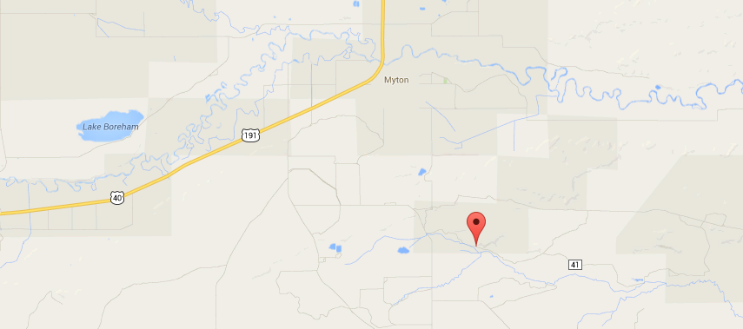
The two SBATS failed quickly, both had been tested repeatedly. Both flew the day before after being cleaned from a water landing. The WB1SAR unit died within seconds of launch. The KF7WII unit lasted a few minutes. We were able to visually track the flight until burst. We stopped in a parking lot on US-40 west of Bottle Hollow until burst.

