U Mich flight prediction for June 22, run on Saturday night at about 9:30 p.m.

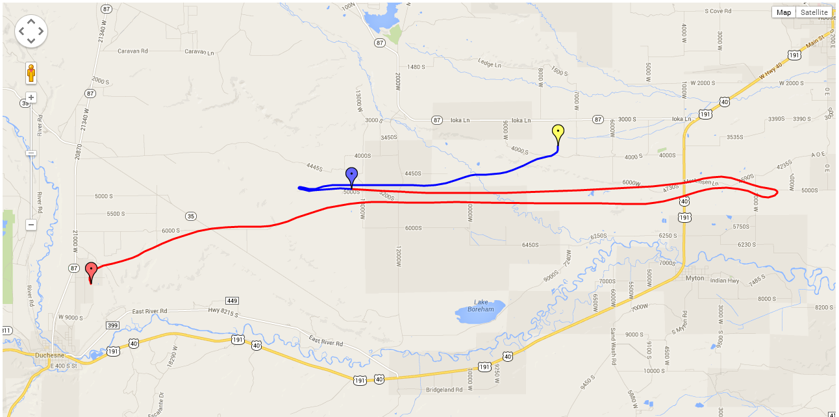

Output Parameters:
Peak Altitude : 29695.0+/-0.0 m
Ascent Rate : 4.86 m/s (957.61 fpm)
Ascent Time : 95.0 minutes
Descent Rate : 17.27 m/s
Descent Time : 27.0 minutes
Total Time : 122.0 minutes
Total Distance Traveled : 41.0 Miles
Distance Between Launch and Landing : 14.0 Miles
Input Parameters:
Starting Latitude : 40.191903
Starting Longitude : -110.38099
Tanks of Helium : 1.75
Balloon Size : 2000.0 g
Parachute Diameter: 8.04672 ft
Payload Weight : 11.9748288 lbs
Launch time : 2014-6-22 16 UT
Images:
