Raw files extensions

.raw - contains date and time stamped comma-separated ASCII data. This file contains the original data transmitted from the iMet radiosonde and other instruments connected to it.

.cfg - contains the configuration information specific to the flight. Both the .raw and
the .cfg files are required to post-process a flight.

.ptu - pressure,temperature, and humidity data from the radiosonde

.gps - data from the GPS showing the package location and GPS time

.wnd for wind data if a GPS is installed

.o3 - ozone data.

Raw files table fields
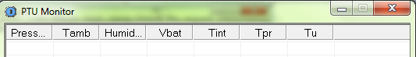
Press = pressure
Tamb = ambient temperature
Humid = humidity
Vbat = radiosonde battery voltage
Tint = radiosonde intern temperature
Tpr = ?
Tu = ?

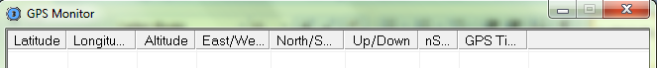
Seems self explanatory

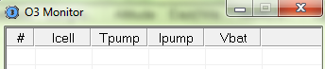
# = ozonesonde number (the software stores up to 4 ozonesonde data)
Icell = current of the chemical cell (the software subtracts background current)
Tpump = temperature of the air pump
Vbat = ozonesonde battery voltage

